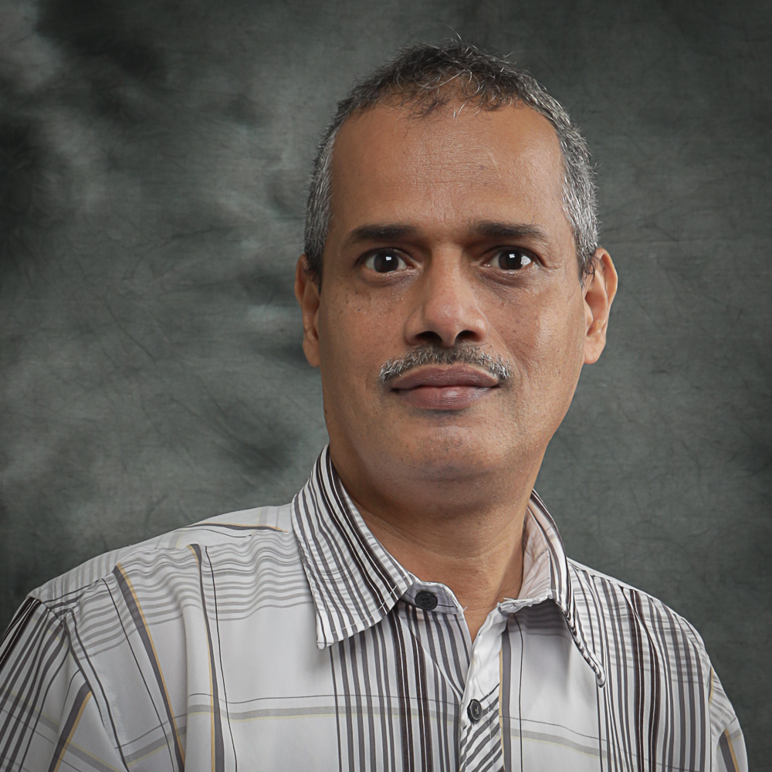 | CURRICULUM VITAE  Associate Professor Dr. Ahmed Mohamed Ahmed Haidar  Faculty of Engineering  Universiti Malaysia Sarawak (UNIMAS)  94300 Kota Samarahan  Sarawak, Malaysia. | 









082-592663 | ahahmed@unimas.my

1. PROFESSIONAL PROFILE

2. ACADEMIC QUALIFICATION
(Qualification), (Discipline), (Institution), (Year)
Doctor of Philosophy, POWER ENGINEERING, Universiti Kebangsaan Malaysia, 2009
Master of Science in, POWER ENGINEERING, Donetsk National Technical Uni, 1994
Bachelor of Science in, POWER ENGINEERING, Donetsk National Technical Uni, 1993

3. PREVIOUS APPOINTMENT
(Post), (Organisation), (From)-(Until)
#{appointmentList}

4. AREAS OF EXPERTISE
(Main), (Sub/Area)
Electrical and Electronic Engineering, Other Electrical and Electronic Engineering n.e.c.

5. RESEARCH
(Project title), (Source), (Role in Project), (From)-(Until)
The Analysis of Soft Error in Asynchronous Circuits Involving C-Elements, Co-Researcher, 2016-2018, Special Short Term Grant
Optimization of a Smart Grid Containing Renewable Energy Resources to minimize Power Blackouts in the State of Sarawak, Head / Project Leader, 2016-2019, Fundamental Research Grant Scheme
DEVELOPMENT OF NEW DIGITAL POWER INFRASTRUCTURE FOR NEW DIGITAL SOCIO-ECONOMY IN SARAWAK STATE, Co-Researcher, 2018-2020, Digital Sarawak CoE
Hybrid Renewable Energy Storage System, Co-Researcher, 2020-2020, Luar (Antarabangsa)
Prototyping of an affordable modular Solar-Powered Absorption Cooling System integrated with Waste Heat Regeneration Reactor and Passive Cooling., Co-Researcher, 2020-2022, Prototype Research Grant Scheme
Formulation and Mitigation of Soft Error in CMOS Memory System, Co-Researcher, 2020-2022, Fundamental Research Grant Scheme
An Intelligent Modelling of Power Router in Cloud Computing Environment for Voltage Management of Grid-connected Renewable Resources, Head / Project Leader, 2021-2024, Fundamental Research Grant Scheme
Kinetics study of boron-carbon arrayed on molybdenum substrates as electrocatalysts for Hydrogen Evolution Reaction (HER), Co-Researcher, 2023-2026, VC High Impact Research Grant 2.0 (VC HIRG2.0)
Agrivoltaic-eletrolysis for hydrogen production, intelligent control and security operations management, Co-Researcher, 2023-2026, VC High Impact Research Grant 2.0 (VC HIRG2.0)

6. CONSULTANCY
(Title)

7. AWARDS AND RECOGNITION
(Name of Awards), (Awarding Institution), (Year), (Level)

8. PUBLICATION
(Publication)
Yiizzan Suffian, Ahmed M.A. Haidar, Tony Ahfock, “An optimized edge-assisted control system for low inertia photovoltaic microgrids in a cloud coordinating environment”, Elsevier, Measurement: Energy, Vol. 10, 1 – 19, 2026.
Isaac J., Haidar A.M.A. and Helwig A. (2026). An enhanced predictive energy management of a green hydrogen integrated microgrid based on correlation analysis considering uncertain conditions. International Journal of Hydrogen Energy, 203(1), 1.
M.M. Ahmed, F.C. Jong, Lau Wei Kin, Ahmed M.A. Haidar, “Operational and economic design of multi-terminal medium DC voltage hybrid renewable energy systems for effective power sharing” Elsevier, Energy Efficiency First, Vol. 2, 1 – 20 2025.
Jordan Isaac, Ahmed M.A. Haidar, M.F.M. Sabri, M.O. Abdullah, Techno-economic analysis and dynamic operation of green hydrogen-integrated microgrid: An application study, Next Energy, Volume 9, 2025, 100418,
ISSN 2949-821X, https://doi.org/10.1016/j.nxener.2025.100418.
A. M. A. Haidar, A. Helwig and L. Moldovan, "An Optimized Load Shedding Approach in Power Grids to Mitigate Cascading Failure," 2025 18th International Conference on Engineering of Modern Electric Systems (EMES), Oradea, Romania, 2025, pp. 1-5, doi: 10.1109/EMES65692.2025.11045624.
Yiizzan Suffian, Ahmed M.A. Haidar, Wan AWZ Abidin, Hazrul M. Basri, "An improved hybrid method combined with a cloud-based supervisory control to facilitate smooth coordination under low-inertia grids," Progress in Engineering Science, 2025.
https://www.sciencedirect.com/science/article/abs/pii/S2950425225000246
Suffian Y., Ahmed Haidar A., Wan Zainal Abidin W. and Basri H. (2024). Integrated Control of Grid-Forming and Grid-Following in Low-Inertia Environments. , 1(1), 1-6.
Isaac J., Ahmed Haidar A., Wan Zainal Abidin W. and Sabri M. (2024). Energy Storage Management of Green Hydrogen-Integrated Microgrid. , 1(1), 1-6.
Lee Shaw L., Ahmed Haidar A. and Vasile-Darie S. (2024). Decentralized Management of Hybrid Energy Systems Considering Uncertainty. Journal of Electrical and Electronics Engineering, 17(2), 1-6.
Ahmed M.A. Haidar, Mohd R. M. Sharip, Tony Ahfock, “An integrated decision-making approach for managing transformer tap changer operation while optimizing renewable energy storage allocation using ANP-entropy and TOPSIS”, Electrical Engineering, Volume 106, pages 2407–2423, (2024).
Ali H.K., Haidar A.M.A., Julai N. and Helwig A. (2023). Voltage Regulation Planning Based on Optimal Grid-Connected Renewable Energy Allocation Using Nature-Inspired Algorithms to Reduce Switching Cycles of On-Load Tap Changing Transformer. Electric Power Components and Systems, 1(1), 1.
Ahmed M. A. Haidar, Lim Wei Han, Tony Ahfock, “Feasibility Analysis of Implementing Hybrid Powered Electric Vehicle Charging Stations in Sarawak”, IEEE Sustainable Power and Energy Conference (iSPEC) 2022. Australia.
Ahmed M. A. Haidar, Fatihah Ramli, Andreas Helwig, “Analysis of Grid-connected Solar PV System Operation based on Energy Router Concept” IEEE Workshop on the Electronic Grid (eGRID 2022), Auckland, New Zealand.
Muhammad Qasim Khan, Musse Mohamud Ahmed, Ahmed M.A. Haidar, "An accurate algorithm of PMU-based wide area measurements for fault detection using positive-sequence voltage and unwrapped dynamic angles", Measurement 192(2022)110906.
Fakhar A., Haidar A., Abdullah M. and Das N. (2022). Smart grid mechanism for green energy management: a comprehensive review. INTERNATIONAL JOURNAL OF GREEN ENERGY, 1(1), 1-25.
Ahmed M. A. Haidar, Lai Carmen, Kashem M. Muttaqi, “A Market Framework for Energy Bidding Decision-Making Strategy to provide a Competitive Mechanism in the Context of Deregulated Electricity Market”, IEEE International Conference on Computing, Power and Communication Technologies, 2021. Malaysia.
Singkang L.M., Ping K.A.H., Kunsei H., Senthilkumar K.S., Pirapaharan K., Haidar A.M.A. and Hoole P.R.P. (2021). Model based-testing of spatial and time domain artificial intelligence smart antenna for ultra-high frequency electric discharge detection in digital power substations. Progress In Electromagnetics Research M, 99(1), 91-101.
Haidar A.M.A., Smith V. and Elphick S. (2021). A multipurpose problem-based learning platform for education and research under smart grid umbrella. International Journal of Electrical Engineering Education, 58(1), 3-32.
1. Ahmed M.A. Haidar, Adila Fakhar, Kashem M. Muttaqi, “An Effective Power Dispatch Strategy for Clustered Micro-grids while Implementing Optimal Energy Management and Power Sharing Control using Power Line Communication”, IEEE Transactions on Industry Applications, Vol. 56 (4), 1 – 14.
Ahmed M.A. Haidar, Adila Fakhar, Andreas Helwig, “Sustainable energy planning for cost minimization of autonomous hybrid microgrid using combined multi-objective optimization algorithm”, Sustainable Cities and Society 62 (2020) 102391, 1- 20.
Shahid Ullah, Ahmed M.A. Haidar, Paul Hoole, Hushairi Zena, Tony Ahfock, “The Current State of Distributed Renewable Generation, Challenges of Interconnection and Opportunities for Energy Conversion based DC Microgrids”, Journal of Cleaner Production, In Press, 2020.
Shahid Ullah, Ahmed M. A. Haidar, Hushairi Zen, (2020) “Assessment of technical and financial benefits of AC and DC microgrids based on solar photovoltaic”, Springer, Electrical Engineering, (2020) 1-14.
Shahid Ullah, Ahmed M.A. Haidar, Kashem M. Muttaqi, Tony Ahfock, “A Distributed Secondary Control Strategy for Power Sharing and Voltage Regulation by Multiple Converters in DC Micro-grids,” IEEE Inter. Conf. on Electrical, Control and Instrumentation Engineering, 2019, Malaysia.
Ahmed M. A. Haidar, Heng Wei Hau “A Framework for Placement Assessment of Synchrophasor Measurement in Practical Power Grid: A Case Study from Borneo,” Journal of Electrical and Electronics Engineering, Vol. 12, nr 2, pp. 11 – 16 , Oct. 2019
Ahmed M.A. Haidar, Adila Fakhar, Kashem M. Muttaqi, “An Effective Power Dispatch Strategy for Clustered Micro-grids while Implementing Optimal Energy Management and Power Sharing Control using Power Line Communication”, IEEE Industry Application Annual Meeting, Baltimore, USA, 2019.
Ahmed M.A. Haidar, Norhuzaimin Julai, "An improved scheme for enhancing the ride-through capability of grid-connected photovoltaic systems towards meeting the recent grid codes requirements," Energy for Sustainable Development, 50 (2019) 38–49.
Mohd R. M. Sharip, Ahmed M. A. Haidar, Aaron C. Jimel, (2019). Optimum Configuration of Solar PV Topologies for DC Microgrid connected to the Longhouse Communities in Sarawak, Malaysia: International Journal of Photoenergy, Volume 2019, Article ID 2657265, 13 pages.
Julai N., Haidar A.M.A. and Kram A.R. (2018). The analysis of soft error in c-elements. Indonesian Journal of Electrical Engineering and Computer Science, 10(3), 1013-1022.
A. Balqis Z. Khan, Ahmed M. A. Haidar &Al-Khalid bin Hj Othman (2018) Contingency Analysis of a Power Grid with the Participation of Utility-Scale Solar PV Units: A Case Study from Sarawak, Malaysia. 2018 IEEE International Conference on Power and Energy
Muhammad Qasim Khan Musse Mohamud Ahmed, Ahmed M. A. Haidara, Norhuzaimin Julai Mohammad Kamarul Hasan (2018)Synchrophasors Based Wide Area Protection and Phasor Estimation : A Review
Adila, Fakhar and Ahmed Mohamed, Ahmed Haidar and Musse, Mohamud Ahmed and Rahman, A. K. (2018) Sustainable Energy Management Design for Bario
Microgrid in Sarawak, Malaysia. In: 2018 IEEE International Conference on Power and Energy (PECon2018)
Askari, M., Moghavvemi, M., Almurib, H.A.F., Haidar, A.M.A. 2017. Stability of Soft-Constrained Finite Horizon Model
Predictive Control. IEEE TRANSACTIONS ON INDUSTRY APPLICATIONS. vol.53, 6, 5883 - 5892
A Review of Sarawak Off-Grid Renewable Energy Potential and Challenges(2017). Journal of Telecommunication, Electronic and Computer Engineering.,9,3-10,29-33
Haidar, A. M. A., Bin Hj Othman, A. -., & Lopes, L. A. C. (2017). Flexibility-based anti-islanding protection of a microgrid integrated with power grid. Paper presented at the 2017 5th IEEE International Conference on Smart Energy Grid Engineering, SEGE 2017, 38-45. doi:10.1109/SEGE.2017.8052773
Ahmed M.A. Haidar, Kashem M. Muttaqi, Mehrdad Tarafdar Hagh, “A Coordinated Control Approach for DC link and Rotor Crowbars to Improve Fault Ride-Through of DFIG based Wind Turbine”, IEEE Transactions on Industry Applications, Vol. 53, No. 4, July/August 2017.
Ahmed M.A. Haidar, Chellali Benachaiba, Norhuzaimin Julai, MohamedFareq AbdulMalek, “Parameters Extraction Of Unified Power Quality Conditioner On The Calculation Of A Membership Function”, International Journal on Electrical Engineering and Informatics, Vol. 9, No. 2, June 2017.
Hikma Shabani, Ahmed M.A. Haidar, Norhuzaimin Julai, Musse M. Ahmed, P.R.P Hoole, Majdi Marai, “Adaptive Algorithm for Optimal Route Configuration in Multi-Hop Wireless Sensor Network”, International Journal of Control Theory and Application, Vol. 10, No. 16, 2017.
C Benachaiba, B Mazari, MN Tandjaoui, Ahmed M.A. Haidar, “Power quality enhancement using DVR based on ant colony controller”, IEEE International conference on Power and Electrical Engineering, Riga, Latvia, 2016.
Jaalam, N., Rahim, N. A., Bakar, A. H. A., Tan, C., & Haidar, A. M. A. (2016). A comprehensive review of synchronization methods for grid-connected converters of renewable energy source. Renewable and Sustainable Energy Reviews, 59, 1471-1481. doi:10.1016/j.rser.2016.01.066
Ahmed M.A. Haidar, Kashem Muttaqi, “Behavioral Characterization of Electric Vehicle Charging Loads in a Distribution Power Grid through Modeling of Battery Chargers”, IEEE Transactions on Industry Applications, Vol. 52, No. 1, 2016.
Ahmed M.A. Haidar, Mehrdad T. Hagh, Kashem M. Muttaqi, “Improving Low Voltage Ride-Through using Super Capacitor at the DC Link of Doubly-fed Induction Generator based Wind Turbine”, 50th Intern. Universities Power Engineering Conf., 1st - 4th September, Staffordshire University, UK, 2015.
Mehrdad T. Hagh, Kashem M. Muttaqi, Danny. Sutanto, M. S. A. Hossain, Ahmed M.A. Haidar, “Improving Fault Ride-through Capability of Doubly-fed Induction Generator based Wind Generators by Bridge-type Superconducting Fault Current Limiter”, 50th International Universities Power Engineering Conference, 1st - 4th September, Staffordshire University, UK, 2015.
Ahmed M.A. Haidar, Kashem Muttaqi, M. H. Haque “Multi-stage Time-variant EV Load Modeling for Capturing Accurate EV Behavior and EV Impact on Electricity Distribution Grids”, IET Generation, Transmission & Distribution, Vol. 9, Issue 16, 2015, p. 2705 – 2716.
Ahmed M.A. Haidar, Kashem M. Muttaqi, “Effects of PEV Penetration on Voltage Unbalance”, Springer Singapore, Plug-In Electric Vehicles in Smart Grid, Book Chapter 10, 279 – 307, 2015.
Ahmed M.A. Haidar, Kashem Muttaqi, Danny Soetanto, “Smart Grid and its Future Perspectives in Australia”, Elsevier, Renewable & Sustainable Energy Reviews, 51, pp. 1375–1389, 2015.
Ahmed M.A. Haidar, Kashem M. Muttaqi, Danny Soetanto, (2014) Technical Challenges for Electric Power Industries due to Grid-Integrated Electric Vehicles in Low Voltage Distributions: A review”, Elsevier, Energy Conversion and Management, 86, 689–700, 2014.

9. POST GRADUATE SUPERVISION
(Student’s Name), (Degree), (Thesis Title), (Year Awarded),
(Status), (Role)
Shahid Ullah, PHD, Techno-economic Analysis Of Dc Microgrid And Its Distributed Control Strategies With Fault Current Mitigation Technique For Power Sharing And Voltage Regulation, 2024, Completed, Main Supervisor
Adila Fakhar, MBR, Energy Management Strategies For Optimal Hybrid Microgrid Configuration In The Smart Village Context, 2019, Completed, Main Supervisor
Md Abu Sayed, MBR, Development Of Blockchain-based Secure Wide Area Measurement System For Smart Grid Integration, 2026, In Progress, Main Supervisor
Izzah Syafiqah Binti Redzuan, MBR, Null, - , In Progress, Main Supervisor
Jordan Isaac Alistair Ding Wan, MBR, a Predictive Correlation Index–based Energy Management Strategy For Green Hydrogen–
integrated Microgrids, - , In Progress, Main Supervisor
Yiizzan Bin Suffian, MBR, No Change, - , In Progress, Main Supervisor
Jong Far Chen, MBR, Hybrid Spatial-artificial Intelligence Approach For Renewable Energy Sources Sites Identification And Integration In Sarawak State, 2022, Completed, Co Supervisor
Harmen Muda, PHD, Null, - , In Progress, Co Supervisor
Ephrem Ryan Anak Alphonsus, PHD, Agrivoltaic-electrolysis For Hydrogen Production, Intelligent Control And Security Program Management, - , In Progress, Co Supervisor
Muhammad Qasim Khan, MBR, Development Of Phasor Measurement Unit Based Fault Detection And Faulty Line Classification In Electrical Power System, 2019, Completed, Co Supervisor

10. TEACHING
(Course name), (Code)





Electrical Power System , Electrical Power System, Integrated Design Project 1, Final Year Project I, Final Year Project II, Signal and Systems, Electrical Lab 1, Industrial Training, Numerical Method and Statistics, Integrated Design Project 2, Power System Analysis, Numerical Methods and Statistic, Numerical Methods and Statistics, Power System Protection, Electrical Lab 2, Energy Economics and Planning, Analog Electronics, Engineering Ethics, Electrical Machines

