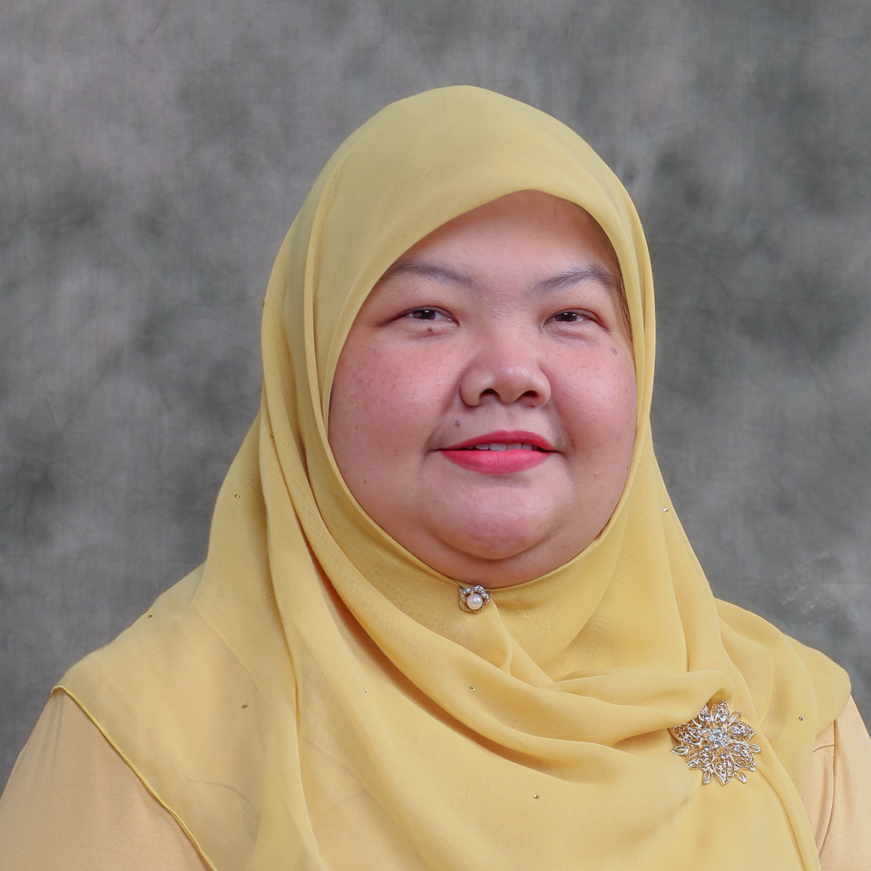 | CURRICULUM VITAE  Associate Professor Dr. Amalia bt Madihie  Faculty of Cognitive Sciences and Human Development  Universiti Malaysia Sarawak (UNIMAS)  94300 Kota Samarahan  Sarawak, Malaysia. | 









082-581491 | mamalia@unimas.my

1. PROFESSIONAL PROFILE
Amalia Madihie is a counsellor educator at Counselling Programme, Faculty of Cognitive Sciences and Human Development, Universiti Malaysia Sarawak. She is currently a Dean at the same faculty. Amalia actively engages her research interest in resilience studies with local and international partners. Her contribution to research, publication, innovation and commercialization is vast as she is the author of Resilient Therapy Intervention and REBT Intervention focusing on self-concept in individuals and Resilience Assessment Tool (RAT-43). Both instruments are used widely in Malaysian context. Amalia is a licensed and registered counsellor in Malaysia. She also practices her counselling at private clinic and provides counselling to children, adolescents and families. Amalia is a member of Persatuan Kaunseling Malaysia Antarabangsa (PERKAMA International), International Association for Counselling (IAC) and American Psychological Association (APA). Another new adventure in her research ecosystem is providing clinical counselling works to community.

2. ACADEMIC QUALIFICATION
(Qualification), (Discipline), (Institution), (Year)
Doctor of Philosophy, Guidance and Counseling, Universiti Putra Malaysia, 2015
Master of Science, Counselling Psychology, LEE UNIVERSITY, 2004
Bachelor of Science in, Sains Kognitif, Universiti Malaysia Sarawak, 2000

3. PREVIOUS APPOINTMENT
(Post), (Organisation), (From)-(Until)
#{appointmentList}

4. AREAS OF EXPERTISE
(Main), (Sub/Area)
Psychology, Counselling and Psychotherapy
Cognitive Science, Philosophy of Cognition
Youth Problems, Youth Problems
Social Science, Social Science

5. RESEARCH
(Project title), (Source), (Role in Project), (From)-(Until)
The Effect of 30-Minute Mindful Breathing in Reducing Fatigue among Patients with Haematological Cancer – A Randomized Controlled Trial., Co-Researcher, 2019-2021, Cross Disciplinary Research
Blogging as a New Reflection Tool for Trainee Counselors, Co-Researcher, 2016-2017, Scholarship of Teaching and Learning Grants
Development of The Resilience Assessment Tool and A Cross-Cultural Investigation of the Resilience Framework Through Q-Methodology, Head / Project Leader, 2016-2017, Small Grant Scheme (Not offered starting from 2021-rebranding to PILOT)
Pembuatan keputusan kerjaya pelajar sekolah-sekolah Pedalaman Sabah dan Sarawak : Kajian kes dalam kalangan Pelajar Multi Etnik, Ibu Bapa dan Profesional Bidang Kerjaya., Head / Project Leader, 2017-2019, Luar (Nasional)
Intelligent Vision based Digital Mirror for Depression Support & Client Management System, Head / Project Leader, 2018-2020, Special MyRA Assessment Funding 1
Old Kuching Branding Souvenir Product (Merchandise) and Services
(OKH), Co-Researcher, 2018-2019, UHSB ( Contract Research )
Strategic Development, Implementation and Assessment of Counselling Undergraduate Programme, Co-Researcher, 2019-2020, Scholarship of Teaching and Learning Grants
Mind Transformation by Applying Resilience Approach through Psychoeducational Programme for B40 Family Children in Kota Samarahan, Head / Project Leader, 2019-2020, UHSB ( Contract Research )
Depression - Chat Online Analysis, Co-Researcher, 2021-2021, UHSB (Industrial Grant)
Malaysian Adolescents Resilience Study, Head / Project Leader, 2021-2022, UHSB ( Contract Research )
Dee Hati Grief Module Development Study, Co-Researcher, 2022-2023, UHSB (Industrial Grant)
Smart Museum Framework, Co-Researcher, 2022-2024, Padanan (Antarabangsa)
Orphaned-Children Resilience Model in Managing Grief: Developing Best Practice Model, Head / Project Leader, 2023-2026, Fundamental Research Grant Scheme
Development of a Brief Dialectical Behaviour Therapy Skills Training Group Module to Improve the Academic Performance of Undergraduate Students in a Public University in Malaysia, Mentor, 2025-2027, null
Assessing the Impact of Psychological Module among Rural Schools, Co-Researcher, 2025-2028, UHSB (Industrial Grant)
Kajian Impak Konsep Human Resilience Library dalam Mengoptimakan Kesihatan Mental dan Kesejahteraan Komuniti, Co-Researcher, 2026-2026, Geran Penyelidikan Pendayaan dan Anjakan SDG
Kajian Impak Bantuan Psikososial Pasca Banjir Terhadap Kesejahteraan dan Daya Tindak Mangsa, Co-Researcher, 2026-2026, UHSB (Industrial Grant)

6. CONSULTANCY
(Title)
Cadangan Projek/Program MKMF Kampung Jagoi, Bau, Sarawak bagi Tahun 2016, Kementerian Pertanian dan Industri Asas Tani Malaysia Bahagian Pengairan dan Saliran Pertanian, Project Manager, 2016 - 2017, National
Cadangan Projek/Program MKMF Kampung Jagoi, Bau, Sarawak bagi Tahun 2016, Kementerian Pertanian dan Industri Asas Tani Malaysia Bahagian Pengairan dan Saliran Pertanian, Project Manager, 2016 - 2017, National
As Counsellor for Sarawak Energy Employee Assistance Programme (EAP) from 01 Dec 2018 to 30 Nov 2020, Sarawak Energy Berhad, Head / Project Leader, 2018 - 2020, National
Seismic and Geological Soil Mapping for Sarawak-Sabah Link Road (SSLR) Phase 2 and Social Support for the Local School Communities, Maltimur Aktif Unggul JV Sdn Bhd, Project Manager, 2025 - 2027, National

7. AWARDS AND RECOGNITION
(Name of Awards), (Awarding Institution), (Year), (Level)

8. PUBLICATION
(Publication)
Mohd. Shahrul Kamaruddin, Amalia Madihie, Salmah Mohamad Yusuff, Chong Siew Kian, Maizatul Mardiana Harun, Aini Azeqa Ma’rof (2026). Empowering Students: The Role of Rational Emotive Behavior Therapy in Overcoming Exam-Related Depression. International Journal of Research and Innovation in Social Science (IJRISS), 10(3), https://doi.org/10.47772/IJRISS.2026.100300504.
Zahit, R. A. ., Madihie, A. ., Mohamad Yusoff, S., Hutasuhut, I. J., Abu Bakar, M. A., Barawi, M. H., Junaini, S. N., & Nur Haziyah Amni Raimaini. (2025). Classifying depression severity in online chats through human-coded psycholinguistic analysis using DSM-5 and Beck Depression Inventory. Journal of Cognitive Sciences and Human Development, 11(2), 214–231. https://doi.org/10.33736/jcshd.10058.2025
Xia W., Madihie A. and Sze S. (2025). Translation and psychometric evaluation of the Chinese version of the Mathematical Resilience Scale. Acta Psychologica, 259(1), 1-9.
https://spj.science.org/doi/epdf/10.34133/jemdr.0005
Khan R.U., Oon Y.B., Madihie A.B.T., Bin Barawi M.H., Hutasuhut I.J., Ranudinata H.N. and Kristanto D.D. (2025). FROM STATIC DISPLAYS TO INTERACTIVE AR: EVALUATING THE EFFECTIVENESS OF AN AR APP FOR GEN Z AND ALPHA IN MUSEUM PUSAKA. Journal of Theoretical and Applied Information Technology, 103(10), 4069-4070.
Motevalli S, Razak RA, Bailey RP, Amalia Madihie, Mehdinezhadnouri, K., & Pan, Y. Parents’ Sharenting Behaviours: A Systematic Review of Motivations, Attitudes, Perceptions, and Impression Management Perspectives F1000Research 2025, 14:448
Chen J. and Madihie A. (2025). Reliability and Validity Evaluation of the RAT-43 Psychological Resilience Scale in Chinese Adolescents. Communications on Applied Nonlinear Analysis, 32(10s), 2030-2042.
Khan A., Madihie A., Ullah F., Abid O. and Awan K. (2025). A comparative exploration of eye movement desensitisation and reprocessing versus cognitive behavioural therapy for post- traumatic stress disorder in Pakistan: Insights from a full- fledged randomised controlled trial. Counselling & Psychotherapy Research, 25(1), 1-15.
Anwar, K., Amalia, M. and Rehman, U.K. (2024) . Cultural Adaptation of Evidence-Based Psychotherapies for Common Mental Health Disorders in Pakistan, Bentham Science Publishers. https://doi.org/10.2174/97898152742571240101
Aris Saputra N., A. M., M. M., Sobri A., Madihie A. and Fitriyah F. (2024). Digital Literacy asan Indicator of Adolescent Mental Health and Implementation for the Role of School Counselor : A Systematic Literature Review. South Eastern European Journal of Public Health, XXIII(3), 221-234.
Khan, A., & bt Madihie, A. (2024). Eye Movement Desensitization and Reprocessing Therapy in Children Experiencing Mental Health Challenges. In Handbook of Research on Child and Adolescent Psychology Practices and Interventions (pp. 303-323). IGI Global
Zahit R. A, Madihie A., Mohamad Yusof, S., Hutasuhut, I. J. and Abu Bakar M.A. (2022). Psycholinguistic Analysis of Online Chat in Detecting Signs of Depression and Other
Mental Health Issues. , 1(1), 19-19.
Kamis M.S, Sahmat M., Singki S., Satiman L. and Madihie A. (2022). Pendekatan pendidikan atas talian ketika pandemik dalam perspektif hal ehwal jaringan kemasyarakatan setempat. Dalam Standing Alone Together: Managing the Paradox (pp. 237-254), PERKAMA International Persatuan Kaunseling Malaysia Antarabangsa.
Kamis M., Alias M., Sahmat M., Singki S., Satiman L., Madihie A. and Zamri F. (2022). Approach of Self-Control Therapy Based on The Arabic Terms of ‘Maqasid Syariah’ Towards the Views of Malaysian Students Falling in Love and Having Suicidal Thoughts. , 1(1), ID 098-ID 098.
Diana Leh-Ching N., G. G. G., Anuar N., Yu-Zhen T., Natalie‑Zi L., Yi‑Wen T., Mohd Said S., Madihie A., Chee Shee C. and Seng Beng T. (2021). The effect of a single session of 30-min mindful breathing in reducing fatigue among patients with haematological cancer –a randomised controlled trial. BMC Palliative Care, 20(160), 1-9.
Afnibar Afnibar, Amalia Amalia, Dyla Fajriani Nasrul, & Aulia Rahmi. (2020). Children's Worth School: Psychological Well-Being of High School Students in Padang, Al'Talim Journal, 27(2), 215-226.
Len, N., Madihie, A., & Yusoff, S. M. (2020). Effects of Cognitive Therapy Intervention (CTI) on the Resilience with Problematic Behavior Among the Adolescents. International Journal of Academic Research in Progressive Education and Development, 9(2), 276–288.
Md. Rahimullah Miah, Mir Abu Saleh Shamsuddin, Alexander K Sayok, Mohamed Sharif Mustaffa, Surena Sabil, Amalia Madihie and Jamayah Saili 2018. Dynamic Reflections of Environmental Education towards Educational Institution. Singaporean Journal of Social Science, v.1, no.1, pg.27-35.
Yao Xiong T., Madihie A., Saili J., Abu Bakar M., Abu Bakar R. and Mahmud M. (2020). The Relationship Between Suicidal Ideation and Cognitive Distortion Among Undergraduates. Malaysian Journal of Social Sciences and Humanities (MJSSH), 5(9), 30-38.
Ishak N., Mat Yusoff N. and Madihie A. (2020). Resilience in Mathematics, Academic Resilience, or Mathematical Resilience?: An Overview. Universal Journal of Education Research, 8(5A), 34-39.
Khan, R. U., Bee, O. Y., M, Amalia & Chia, S. E., (2019). Indoor Navigation Systems Using Annotated Maps in Mobile Augmented Reality. International Journal of Innovation, Creativity and Change (IJICC), 8(2), 1-14.
Binti Mohamad Yusoff S., Anak Temeling G., Binti Mohd Said S., Bin Abu Bakar M. and Binti Madihie A. (2018). Modul psiko-pendidikan persediaan menghadapi menopaus. , 1(1), 62-67.
Mohamed Sharif Mustaffa, Md Rahimullah Miah, Amalia Madihie, Prashanth Talwar Yadar. (2018). Towards effective counseling approaches and contextual factors enhanced diversity collaboration. International Journal of Engineering & Technology, (Accepted).
Md. Rahimullah Miah, Mohamed Sharif Mustaffa, Surena Sabil, Amalia Madihie, Jamayah Saili , Alexander Kiew Sayok. (2018). Towards dynamic policy for early childhood development enhanced the growth of self-regulations. International Journal of Engineering and Technology (Accepted).
Khan, A., Leong, P. S., Sanil, S. H., Mohamed Sharif Mustafa, Amalia Madihie, & Surena Sabil. (2018). Effect of personality traits and Learning Styles towards Students' Academic Achievement in Johor Bahru. International Journal of Engineering and Technology, 7(2), 4-9.
A COUNSELLING MODULE: THE JOURNEY TO HEALTHIER ME
Mohamed Sharif Mustaffa, Amalia Madihie, Prashanth Talwar Yadar and Aqeel Khan. (2017). Counsellors Practices of Ethnic and Religious Factors in Secondary Schools. Man in India.
Mustaffa M., Samuel C., Madihie A., Saili, J. and Khan A. (2017). Psychological Stresses among Divorced Professional Women. , 24(1), 346-349.
Siti Norazilah M. S., Nisha Nurshazwani, B., Shaira Parveen, H., Amalia, M. and Salmah, M. Y. (2017). Development of Mindfulness Module for Promoting Healthy Lifestyle among Female Students in Higher Education Institutions. International Journal of Business and Society, Vol.18, S4 .
Madihie A., Mohamad Yusoff S., Saili J. and Mohd Said S. (2017). Spiritual Domain in Resilience Framework. , 1(1), 62.
Siti Norazilah M. S., Nisha Nurshazwani, B., Shaira Parveen, H., Amalia, M. and Salmah, M. Y. (2017, October). Development of Mindfulness Module for Promoting Healthy Lifestyle among Female Students in Higher Education Institutions [Abtract]. Proceedings of the UNIMAS Silver Jubilee Conference 2017.(pp.143). Retrieved from http://ir.unimas.my/id/file/303263
Salmah Mohamad Yusoff, Amalia Madihie & Siti Norazilah Mohd Said (2017). Blogging as a new reflection tool for trainee counsellors. SoTL Bulletin, 1, p. 9
Amalia Madihie, Sidek Mohd Noah, Maznah Baba, & Wan Marzuki Wan Jaafar. (2017). Buku Manual: Rasional Emotif Tingkah Laku. Selangor: PERKAMA Publisher
Amalia Madihie, & Sidek Mohd Noah. (2013). An application of the Sidek Module Development in REBT counseling intervention module designs for orphans. Procedia- Behavioral and Social Sciences, 84, pp.1481-1491.

9. POST GRADUATE SUPERVISION
(Student’s Name), (Degree), (Thesis Title), (Year Awarded),
(Status), (Role)
Nasir Bin Len, PHD, Pembinaan Modul Intervensi Terapi Kognitif Dan Kesan Ke Atas Resilien Remaja Sekolah, 2023, Completed, Main Supervisor
Qin Chao, PHD, The Influence Mechanism Of College Students' Self-compassion On Academic Procrastination, - , In Progress, Main Supervisor
Sangin Juat, PHD, Resilien Kerjaya Sebagai Moderator Hubungan Kematangan Kerjaya Dan Kebolehpasaran Graduan Kolej Vokasional, - , In Progress, Main Supervisor
Fatin Hamizah Jemat, PHD, Null, - , In Progress, Main Supervisor
Marlizawati Mohamat, PHD, Tahap Daya Tahan (resilience) Pelajar Ipta Yang Mengalami Kemurungan (depression) Dan Kebimbangan (anxiety), - , In Progress, Main Supervisor
Wang Xia, PHD, Development And Evaluation Of a Chinese Resilience Module On Mathematical Resilience Among Calculus Students In China, - , In Progress, Main Supervisor
Anwar Khan, PHD, Adapting And Testing Of Emdr Therapy Protocol For Major Depressive Disorder In Pakistan, - , In Progress, Main Supervisor
Zheng Shuai, PHD, The Importance Of Emotional Intelligence For High-level Coaching In Sports, - , In Progress, Main Supervisor
Chen Jing, PHD, Title Remain, - , In Progress, Main Supervisor
Nor Radhiah Binti Chee, PHD, Parental Involvement In Children's Mental Health: Examining The Role And Impact On Positive Parent-child Relationships, - , In Progress, Main Supervisor
Siti Noorfairuz Binti Serbini, PHD, Hubungan Antara Iklim Sekolah Dan Keletihan Emosi Dalam Kalangan Guru Sekolah Menengah: Implikasi Terhadap Gaya Kepimpinan Pengetua., - , In Progress, Main Supervisor
Abg Aidil Bin Abg Abai, PHD, Peranan Amalan Kerohanian Islam Sebagai Mekanisme Kaunseling Dalam Meningkatkan Daya Tahan Remaja: Satu Kajian Empirikal Di Mrsm Borneo, - , In Progress, Main Supervisor
Mohamad Nazwan Bin Mohamad Taufik, PHD, a Lived Experience Dialogue To Enhance Peer Support Acceptance In Malaysian Mental Health Recovery: a Malaysian Perspective, - , In Progress, Main Supervisor
Tan Yao Xiong, MBR, Relationship Between Cognitive Distortion And Suicidal Ideation: The Roles Of Cognitive Factors As Mediators, 2021, Completed, Main Supervisor
Azuwani Binti Mohd Yusoff, MBR, Efikasi Kendiri Sebagai Moderator Dalam Hubungan Metakognitif Terhadap Anggapan Stres Dan Resilien Dalam Kalangan Guru Bimbingan Dan Kaunseling, 2023, Completed, Main Supervisor
Guo Zeqing, MBR, Social Support And Career Choice Anxiety Among Stem Undergraduate Students In China : The Mediating Role Of Mental Resilience, - , In Progress, Main Supervisor
Ahmad Hisyam Bin Ab Hamid, PHD, Pembangunan Sistem Analitik Microsoft Excel Berpandukan Neurosains Kognitif Bagi Penilaian Prestasi Pelajar Dan Intervensi Akademik Melalui Visualisasi Warna, - , In Progress, Co Supervisor
Allen Choong Chieng Hoon, MBR, Augmented Reality Application Builder: Integration Of Finger Tracking For Interaction In Augmented Reality System, 2010, Completed, Co Supervisor

10. TEACHING
(Course name), (Code)





Instrument Development for Counselling, Advanced Counselling Theories, Mentoring and Facilitating Learning, Personality and Individual Differences, Individual Counseling:Tehcniques and Applications, Research Progress, Counselling Assessment, Individual Counselling: Techniques and Applications, Adolescent Counselling, Career Information System, Appreciation of Ethics and Civilization , Counselling Theories and Application II, IT Tools for Knowledge Workers, Personality Development, Final Year Project II, Final Year Project I, Internship, Counselling Lab I (Individual), Final Year Project I, Research Methodology, Final Year Project II, Helping Relationship, Cognitive Psychology, Social Psychology, Abnormal Psychology, Seminar 1: Counselling Practicum, Counselling Lab II (Group), Basic Helping Skills, Introduction To Cognitive Science, Group Dynamic, Introduction to Mental Health, Ethics and Legality in Counselling, Counselling Issues Seminar, Family Counselling, Career Information System

