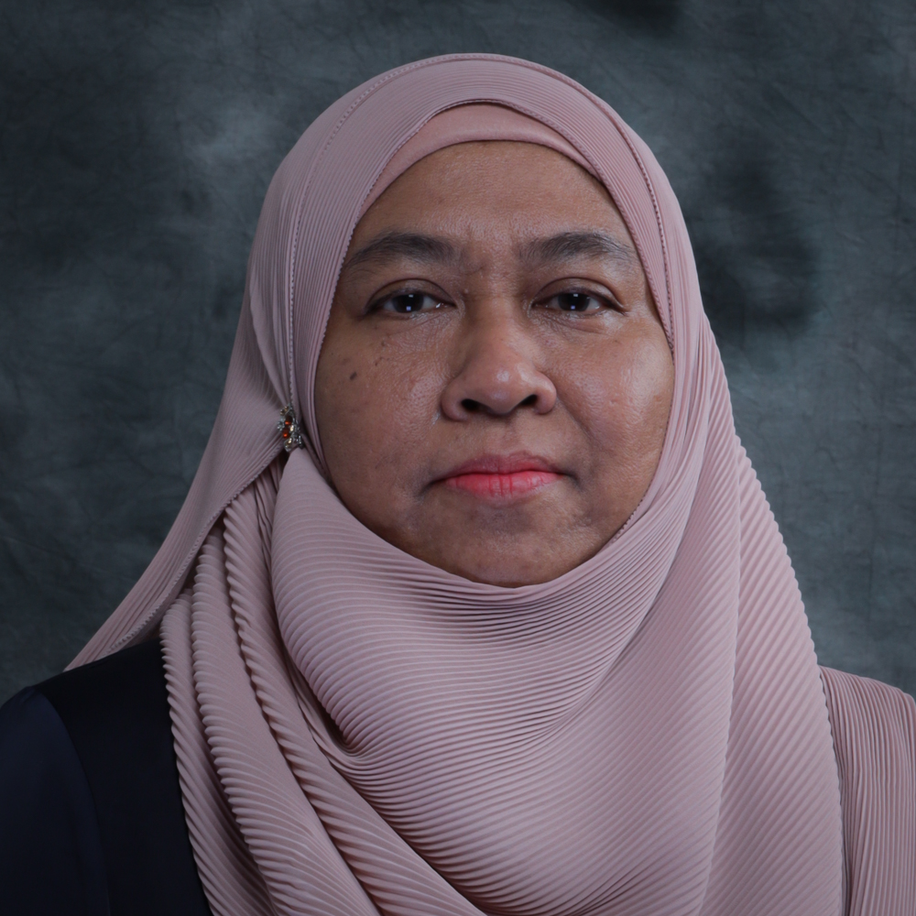 | CURRICULUM VITAE  Associate Professor Dr. Kartini bt Abd Ghani  Faculty of Cognitive Sciences and Human Development  Universiti Malaysia Sarawak (UNIMAS)  94300 Kota Samarahan  Sarawak, Malaysia. | 









082-582820 | gkartini@unimas.my

1. PROFESSIONAL PROFILE
Kartini Abd Ghani is a senior lecturer from the Psychology and Cognitive Science Program at Universiti Malaysia Sarawak (UNIMAS). Her interest involve cognitive processes in memory and learning. She holds a Doctorate degree in Psychology from University of York, UK, a Master in Artificial Intelligence from University of Georgia, US and BA (Hons) Psychology from University of Nottingham, UK. She has experienced administrative posts such as Head of Program, Program Coordinator, Deputy Director (Learning Advancement) and Director at the Centre of Applied Learning and Multimedia.

2. ACADEMIC QUALIFICATION
(Qualification), (Discipline), (Institution), (Year)
Doctor of Philosophy, Psychology, The University of York, 2016
Master of Science, Psychology, University of Georgia, 2004
Bachelor of Arts, Psychology, University of Nottingham, 1997

3. PREVIOUS APPOINTMENT
(Post), (Organisation), (From)-(Until)
#{appointmentList}

4. AREAS OF EXPERTISE
(Main), (Sub/Area)
Psychology, Cognitive Psychology
Cognitive Science, Other Cognitive Science n.e.c
Cognitive Science, Other Cognitive Science n.e.c

5. RESEARCH
(Project title), (Source), (Role in Project), (From)-(Until)
Qeeg Index of Mild Cognitive Impairment for Elderly Group in Sarawak, Co-Researcher, 2013-2015, Fundamental Research Grant Scheme
The exemplar interleaving effect in intuctive learning : the roles of retention interval, repeated training and learning type, Co-Researcher, 2012-2015, Research Acculturation Grant Scheme
The Influence of Emotional Intelligence on Mathematical Achievements of Students with Mathematical Anxiety as Moderator, Co-Researcher, 2016-2018, Special Short Term Grant
Preservation of Dance Knowledge through Interaction Design, Co-Researcher, 2016-2018, Special Grant Scheme
Development of Occupational Emotional Intelligence Index based on Compentency Requirement across High-Risk Occupational, Co-Researcher, 2015-2017, Fundamental Research Grant Scheme
Academic challenges and adjustments of International undergraduates: Implications for teaching and Learning in Higher Institutions, Co-Researcher, 2016-2018, Scholarship of Teaching and Learning Grants
Deriving a Pedagogical Framework for Designing MOOCs, Co-Researcher, 2017-2019, Special FRGS 2016 Cycle
The role of testing in enhancing long-term retention and learning: Moderation by age and gender factors, Co-Researcher, 2018-2020, Special Top Down Grant
Innovative Classroom-Based Strategy: Impact on student’s mathematics motivation, mathematics anxiety, and their mathematics performance., Co-Researcher, 2019-2021, Scholarship of Teaching and Learning Grants
Strategic Development, Implementation and Assessment of Psychology Undergraduate Programme, Head / Project Leader, 2019-2020, Scholarship of Teaching and Learning Grants
Deriving a Guiding Framework for Developing the Scholarship of Curriculum Leadership, Co-Researcher, 2019-2020, Scholarship of Teaching and Learning Grants
Mind Transformation by Applying Resilience Approach through Psychoeducational Programme for B40 Family Children in Kota Samarahan, Co-Researcher, 2019-2020, UHSB ( Contract Research )
EMPOWERING PSYCHOLOGY STUDENTS THROUGH CRITICAL STYLE OF REFLECTIVE PRACTICE IN FORMATIVE ASSESSMENTS, Co-Researcher, 2020-2022, Scholarship of Teaching and Learning Grants
Deriving an Inclusive Pedagogical Model for Multisensory Early Reading Intervention for Young Multilingual Children with Dyslexia, Co-Researcher, 2021-2023, Impact
A Pedagogical Framework on a Multisensory Reading Intervention for Children with Pandemic-Induced Learning Loss, Co-Researcher, 2022-2024, Fundamental Research Grant Scheme
Integrating Art and Wellness: Exploring the Role of Sarawak-Inspired Motifs in Digital Mandala Art Therapy for Youth, Co-Researcher (Next Appointed Leader), 2025-2027, P.RAMLEE RESEARCH CHAIR

6. CONSULTANCY
(Title)

7. AWARDS AND RECOGNITION
(Name of Awards), (Awarding Institution), (Year), (Level)

8. PUBLICATION
(Publication)
Tan, Y. V., Lee, J. A. C., Khan, R. U., Chen, C. J., Ghani, K. A., Juan, S. F. S., & Loh, C. S. B. (2025).
Analyzing the effectiveness of the READi system in helping non-native English-speaking preschoolers in
Sarawak learn the alphabet: A pilot study. Journal of Educational Technology Development and Exchange,
18(2), 25-46. https://doi.org/10.18785/jetde.1802.02
Abu Bakar M., Abd Ghani K. and Zulkiply N. (2025). Working Memory Capacity and Dual-Task Interference in Following Instructions. INTERNATIONAL JOURNAL OF ACADEMIC RESEARCH IN PROGRESSIVE EDUCATION AND DEVELOPMENT, 14(4), 1137-1148.
Abu Bakar M., Abd Ghani K. and Zulkiply N. (2025). The Effects of Working Memory Capacity, Types of Instructions, and Recall on Following Instructions Performance. INTERNATIONAL JOURNAL OF ACADEMIC RESEARCH IN BUSINESS AND SOCIAL SCIENCES, 15(8), 656-670.
Tan Y.V., Lee J.A.C., Khan R.U., Chen C.J., Ghani K.A., Juan S.F.S. and Loh C.S.B. (2025). Analyzing the Effectiveness of the READi System in Helping Non-Native English-Speaking Preschoolers in Sarawak Learn the Alphabet: A Pilot Study. Journal of Educational Technology Development and Exchange, 18(2), 25-46.
Abd Ghani K., Ghazali N., Awang Mat D., Mikal E., Abdul Halim Yun H. and Lukas T. (2024). SoTL Bulletin, Vol.5/2024. , 1(1), 1.
Hannah Tan, Yit Yung and Mohamad Azhari, Abu Bakar and Kartini, Abd Ghani and Ida Juliana, Hutasuhut (2024) Digital Juggling : How Media Multitasking Affects Working Memory Performance Among University Students. Journal of Cognitive Sciences and Human Development, 10 (2). pp. 73-86. ISSN 2550-1623. http://ir.unimas.my/id/eprint/46858
Abu Bakar M., Abd Ghani K. and Zulkiply N. (2023). Reviewing How Individual Differences in Working Memory Capacity Affect the Ability in Following Instructions. Malaysian Journal of Social Sciences and Humanities (MJSSH), 8(7), 1-13.
Abd Ghani, K., Ghazali, N. M., Lucas T. & Awang Mat, D. A. (Eds.) (2023). Real Application of Transformative Approaches for Teaching and Learning in the 21st Century. UNIMAS Publisher.
Hutasuhut I., Abu Bakar M., Abd Ghani K. and Bilong D. (2023). Fostering Self-Directed Learning in Higher Education: The Efficacy of Guided Learning Approach among First-Year University
Students in Malaysia. Journal of Cognitive Sciences and Human Development, 9(1), 221-235.
Bakar, M.A.A., Ghani, K.A., Hutasuhut, I.J., Saili, J., Zulkiply, N., &Ibrahim. N.H. (2022). Engaging students in a critical style of reflective practice through formative assessment. In the 3rd UNIMAS SoTL Symposium 2022, 21 September 2022, DeTAR Putra UNIMAS.
Abd Ghani K., Lucas T., Ghazali N., Abdul Halim Yun H., Awang Mat D. and Wan Zain S. (2022). Garis Panduan Pembangunan Program Akademik Pembelajaran Terbuka dan Jarak Jauh (Open and Distance Learning - ODL) UNIMAS. , 1(1), 1.
Prashanth T., Rethinasamy S., Binti Abd Ghani K., Kock Wah T. and Mat Yusoff N. (2022). Sociodemographic Determinants of Acculturation Stress Among International University Students. EDUCATUM Journal of Social Science, 8(1), 23-30.
Azizan F., Rahim N., Shelda Siaw E., Abd Ghani K. and Sathasivam S. (2022). Innovative Classroom Strategy: Impact on Students’ Mathematics Motivation, Anxiety and Achievement in Pre-University Studies. International Journal of Information and Educational Technology, 1(1), 1-6.
Abu Bakar M., Abdul Ghani K., Hutasuhut I., Saili J., Zulkipli N. and Ibrahim N. (2020). Integrating Reflective Practice and Personalised Feedback in Students’ Learning Experience. , 1(1), 1.
Abd Ghani K., Jun Choi L., Bujang S., Hutasuhut I., Saili J., Nazaruddin M., Abu Bakar R., Ishak M. and Abu Bakar M. (2020). Strategic Development, Implementation and Assessment of Psychology Undergraduate Programme: A Preliminary Study. SoTL Bulletin, 3(1), 33-38.
Abu Bakar M., Abdul Ghani K., Hutasuhut I. and Saili J. (2020). Reflective Practice, Active Thinking and Academic Performance. SoTL Bulletin, 2(1), 7-7.
Mohamad Azhari, Abu Bakar and Kartini, Abd Ghani and Ida Juliana, Hutasuhut and Jamayah, Saili (2020) Exploring the Growth of Reflective Practice in Higher Education. International Journal of Psychosocial Rehabilitation, 24 (8). pp. 2060-2072. ISSN 1475-7192
Bin Abu Bakar M., Binti Abd Ghani K., Hutasuhut I. and Binti Saili J. (2019). Does Reflective Practice And Personalised Feedback Foster Learning?. , 1(1), 102-105.
Bin Abu Bakar M., Hutasuhut I. and Binti Abd Ghani K. (2018). Guided Learning To Improve Self Directed Learning: A Study Among First Year Psychology Students In Unimas. , 1(1), 1-15.
Hui Hong G., Julia Ai Cheng L. and Abd Ghani K. (2019). Oral Reading Intervention for an English Language Learner: A Single-case Design. Theory and Practice in Language Studies, 9(1), 28-33.
Nur Syafiqa Aqiera @ Falecia Stephanie Clement & Abd Ghani, K. (2017). Exploring Learners Contribution and Experience in Web-Based Collaborative Report Writing. Journal of Cognitive Sciences & Human Development. Vol 2 (2), 1-15pg. UNIMAS Publisher.
Abdul Ghani K. and Choon Ning L. (2016). Does Talking about Emotion Help Eyewitness Memory? The Role of Emotional and Factual Retelling in Memory Accuracy. Journal of Cognitive Sciences and Human Development, 1(2), 1-10.
Prashanth T., Kock Wah T., Abd Ghani K. and Mat Yusoff N. (2016). The Goodness-Of-Fit Of Dass-21models Among University Students. Malaysian Journal of Public Health Medicine, 16(3), 219-226.
Ishak M., Putit Z., Zulkiply N., Abdul Ghani K. and Mat Yusoff N. (2015). Designing Emotional Intelligence Measures For Performance In High-Risk Jobs. UNIMAS Research Update, 1(1), 1.
Abd Ghani K., Melissa Wei Yin K., Chwen Jen C. and Puay Hoon O. (2014). Investigating Strategies for Dyslexia Friendly Online Learning Environment (on-going project). , 1(1), 1.
Abd Ghani, K, & Gathercole, S. E. (2013). Working memory and study skills: a comparison between dyslexic and non-dyslexic adult learners. Procedia Social and Behavioural Sciences, Vol 97, pp 271-277.
and Abdul Ghani K. (2013). Working memory performance, learning and study strategies and learning styles of dyslexic and non dyslexie adult learners. , 1(1), 1.
Atiqah Ismail & Kartini Abd Ghani (2013). Enhancing Deep Understanding in Project-Based Learning in Norazila Abd Aziz, Lily Law, & Mohd Hafizan Hashim (2013). PixeLS: A Compendium of Articles on Learning Sciences. Rethinking Learning, pp 1-9.
Kartini Abd Ghani & Norehan Zulkiply (2008).Different Memory Techniques Different Memory Needs: A Case Study for Undergraduate Science Students. The International Journal of Learning, Volume 15, Issue 3, pp.203-210. Article: Print (Spiral Bound). Article: Electronic (PDF File; 592.933KB).
Norehan Zulkiply, Shahren Ahmad Zaidi Adruce, Kartini Abd Ghani and Po Ling Chen (2008).Gender and Educational Stream Differences in Memory Retention for Verbal and Non-verbal Tasks.The International Journal of Learning, Volume 15, Issue 3, pp.221-226. Article: Print (Spiral Bound). Article: Electronic (PDF File; 566.612KB)
Zulkiply, N., Kabit, M.R., and Abd Ghani, K. (2008). Metacognition: What Roles Does It Play in Students' Academic Performance? The International Journal of Learning, Volume 15, Issue 11, pp. 97-106
D Chincotta, G Underwood, KA Ghani, E Papadopoulou, M Wresinski (1999). Memory span for Arabic numerals and digit words: Evidence for a limited-capacity, visuo-spatial storage system.
The Quarterly Journal of Experimental Psychology: Section A 52 (2), 325-351

9. POST GRADUATE SUPERVISION
(Student’s Name), (Degree), (Thesis Title), (Year Awarded),
(Status), (Role)
Mohamad Azhari Bin Abu Bakar, PHD, No Change, - , In Progress, Main Supervisor
Abilashinee A/p Maran, PHD, Teachers' Efforts To Seek Clarification And Provision Of Feedback In Home- Based Teaching And Learning, - , In Progress, Main Supervisor
Fang Ling, MBR, Blended Learning As a New Approach: Its Challenges And Measures For The Readiness Of General Education Teachers In Colleges And Universities, - , In Progress, Main Supervisor
Mohamad Taha Bin Abol, PHD, Kefahaman Guru Dan Gaya Pembelajaran Dan Teknik Pengajaran Untuk Murid Berkeperluan Khas Di Kelas Program Pendidikan Khas Integrasi Sekolah Menengah, 2024, Completed, Co Supervisor
Zarith Fadila Binti Jamel, PHD, Professional Development Intervention On Preschool Teachers' Knowledge And Practices On Early Reading Instruction In English., - , In Progress, Co Supervisor
Zhou Weichen, PHD, The Influence Of Instructional Humour On Learners' Learning From Video Lectures And Its Cognitive Neural Mechanism, - , In Progress, Co Supervisor
Zhang Minmin, PHD, Teaching Reform From The Perspective Of Embodied Cognitive Philosophy, - , In Progress, Co Supervisor
Mohamad Mahathir Bin Shamsulbahri, PHD, Kesan Directed Activity Related To Texts (darts) Dan Jantina Terhadap Beban Kognitif Dan Pencapaian Murid Dalam Analisis Kualitatif Kimia, - , In Progress, Co Supervisor
Yan Lin, PHD, The Influence Of Criticism Style On Primary School Pupils' Teacher-student Relationship And Behavior Improvement Intentions: The Moderating Effect Of Counterfactual Thinking, - , In Progress, Co Supervisor
Teena Sim, PHD, The Effects Of Music Programme On Language Abilities Of Typical And Atypical Preschoolers: a Case Study Series In Sarawak, 2024, Completed, Co Supervisor
Siti Huzaimah Abdullah, PHD, Tajuk:pembangunan Teknik Pemupukan Kemahiran Berfikir Aras Tinggi Dalam
pengajaran-pembelajaran Sains Tahun 4 Sekolah Rendah., - , In Progress, Co Supervisor
Send Anak Takuk, MBR, Hubungan Antara Gaya Pembelajaran Dengan Motivasi Pelajar Politeknik Kuching Sarawak, 2017, Completed, Co Supervisor
Lim Zi Xiang, MBR, Quantitative Analysis Of Eeg Activity In Mild And Moderately Depressed Young Adult, 2018, Completed, Co Supervisor
Kho Ye Yun, MBR, Development And Validation Of a Comprehensive Questionnaire Assessing Young Children's Screen Media Use And Parental Roles, - , In Progress, Co Supervisor

10. TEACHING
(Course name), (Code)





Sociocultural Dimensions in Education , Research Paper in Learning Sciences, Psychology of Learning for Instruction, Cognitive Science Foundations of Learning Sciences, Cognitive Science: Foundations of Learning Sciences, Research Progress, Social and Cultural Dimensions in Learning and Instruction, Teaching and Learning in Higher Education, Fundamentals in Learning Sciences, IT Tools for Knowledge Workers, Final Year Project II, Final Year Project I, Personality and Individual Differences, Research Methodology, Industrial Training, Cognitive Psychology, Cognition and Learning, Industrial Training, Human and Organizational Behaviour, Human Development Psychology, Psychology of Learning, Cognitive Neuroscience , Cognition and Learning, Psychology of Learning, Cognition and Learning , Psychology of Learning, Soft Skills, Cognition And Learning, Sensory and Perception, Softskills & Basic Volunteerism

