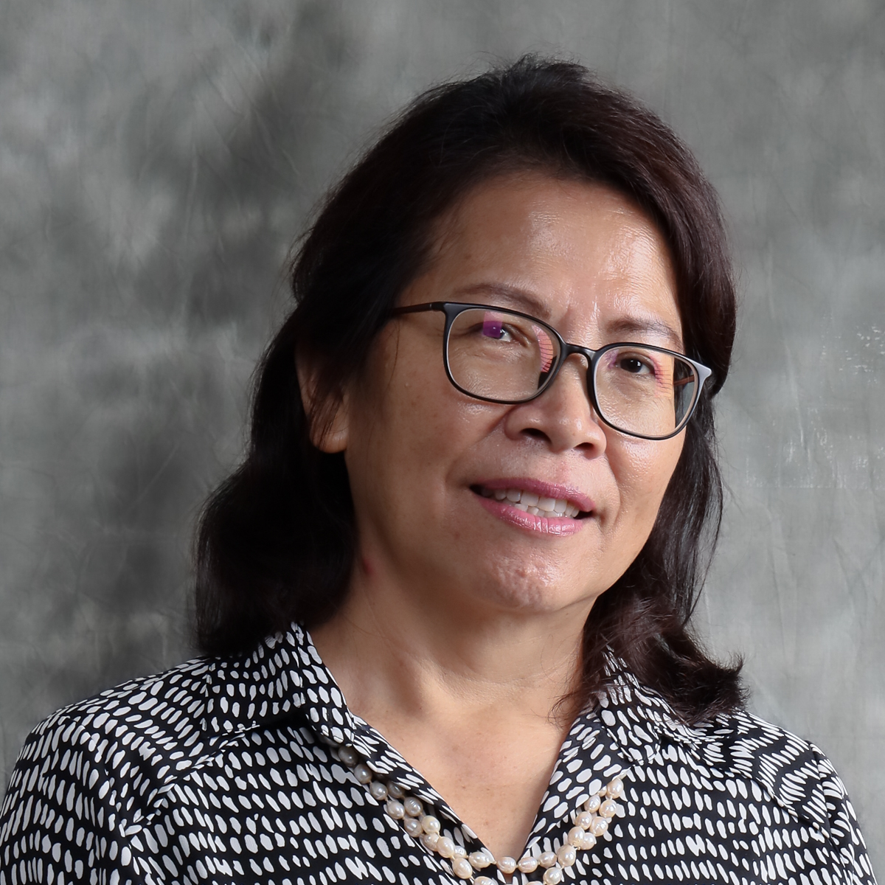 | CURRICULUM VITAE  Professor Dr. Poline Bala  Faculty of Social Sciences and Humanities  Universiti Malaysia Sarawak (UNIMAS)  94300 Kota Samarahan  Sarawak, Malaysia. | 









082-592721 / 2756 | bpoline@unimas.my

1. PROFESSIONAL PROFILE
Poline Bala is a Professor of Anthropology at the Faculty of Social Science and Humanities and the Director of Institute of Borneo Studies at Universiti Malaysia Sarawak (UNIMAS). She obtained her PhD (Social Anthropology) from Cambridge University in 2008.She was a Visiting Scholar at Centre for World Austronesia and Indigenous Peoples (CWAIP), National Tsing Hua, University Taiwan in November 2019. Currently, she is the chair of the Indigenous Digital-Environment System Coalition supported by the UNESCO Chair in ICT4D.
In 2010-2016 she has served as the Head of Department of Anthropology and Sociology at the Faculty of Social Sciences and Humanities and in 2009-2011 as the Deputy Director of the Centre of Excellence in Rural Informatics (Institute of Social Informatics and Technological Innovation) UNIMAS. Poline has been working as a principal researcher, senior research fellow, one of the pioneers of the e-Bario project which is a community-university partnership programme going on for the past 20 years. Her leading roles in the Telecentre Progamme for the Orang Asli Peninsular Malaysia project have shaped the use of technologies to create an immense impact on the lives of over 20 remote and rural indigenous villages. She works to design, plan and implement using a community or people-centered approach, asset-based community development, and participative techniques. All these boil down to her keen interest in societal issues surrounding “marginal and minority people” at the margins of technological advancement and innovation.

2. ACADEMIC QUALIFICATION
(Qualification), (Discipline), (Institution), (Year)
Doctor of Philosophy, Social Antropology, University of Cambridge, 2008
Master of Arts, Asian Studies, Cornell University, 2003
Bachelor of Arts, Asian Studies, Universiti Malaya, 1994

3. PREVIOUS APPOINTMENT
(Post), (Organisation), (From)-(Until)
#{appointmentList}

4. AREAS OF EXPERTISE
(Main), (Sub/Area)
ICT Policy and Social Impact, Digital Divide and E-Inclusion
Sociology of Development, Marginal and Minority Relations
Anthropology, Applied Anthropology
Culture, Culture

5. RESEARCH
(Project title), (Source), (Role in Project), (From)-(Until)
Documenting traditional knowledge: the rural folks' stories of the Kelabit Highlands, Head / Project Leader, 2012-2013, Principal Investigator Fund
Telecentre Programme for Orang Asli West Malaysia , Head / Project Leader, 2013-2018, Luar (Nasional)
Impact Evaluation Study ( Bario, Long Lamai, Ba'kelalan and Long Kerong), Co-Researcher, 2015-2016, Luar (Nasional)
Capacity to Organize Massive Public Educational Opportunities in Universites of Southeast Asia ( COMPETEN-SEA), Co-Researcher, 2016-2019, Luar (Antarabangsa)
Social Innovation for Sarawak's Hinterland, Co-Researcher, 2018-2019, Special Top Down Grant
Forts and Its people: Social History and Collective Memory of Local Communities in Sarawak, Co-Researcher, 2019-2021, Luar (Nasional)
Negotiating Precarity of Undocumented Indigenous Populations in Borneo: A Human Security Approach, Co-Researcher, 2020-2022, Luar (Nasional)
Towards enhancing Malaysia My Second Home programme in Sabah and Sarawak, Co-Researcher, 2020-2022, Luar (Nasional)
Climate Change, Biodiversity And Borneo’s Indigenous Peoples, Head / Project Leader, 2020-2022, Luar (Nasional)
Formulation of TRIZ-based Sustainability-Oriented Innovation Model for Indigenous Knowledge Management, Co-Researcher, 2020-2022, Fundamental Research Grant Scheme
Formulating a Digital Heritage Model for Community-based Preservation and Management of Cultural and Archaeological Sites in the Kelabit Highlands of Sarawak, Head / Project Leader, 2021-2023, Fundamental Research Grant Scheme
Ethnomedicine and Its Potential in Sarawak Borneo, Co-Researcher, 2022-2025, VC-High Impact Research Grant
1.Enhancing People, Public and Private Partnership Model in Managing Santubong Archaeological Heritage Site, Sarawak., Co-Researcher, 2023-2025, PILOT
Community Development Plant for Lang Lebah Community, Co-Researcher, 2024-2024, External Grant
Development of Instruments for Community Engagement and Communication Strategy, Co-Researcher, 2024-2024, External Grant
Social Impact Assessment for Lang Lebah Community, Co-Researcher, 2024-2024, External Grant
From Ritual to Resilience: Exploring Gawai Nyobeng in the Context of Indigeneity, Policy, and Economic Development, Co-Researcher (Next Appointed Leader), 2025-2027, null
A Comparative Analysis of the Impact of Resettlement Policies on the Bidayuh Community in Bengoh Resettlement Area and the Sungai Asap and Murum Resettlement Area, Head / Project Leader, 2025-2027, null
Study and Documentation of Traditional Ethic Musical Instrument In Sarawak, Co-Researcher, 2025-2027, Industri Universiti

6. CONSULTANCY
(Title)
Kajian Social Engineering Pelabuhan Perikanan LKIM Tanjung Bako (PPLTB) di Kuching, Sarawak, Lembaga Kemajuan Ikan Malaysia (LKIM), Head / Project Leader, 2017 - 2018, National
The Study on Sarawak Hydro Lakes Management and Development Plan 2030, AJC Planning Consultants Sdn Bhd, Head / Project Leader, 2018 - 2019, National
SK318 Rosmari and Marjoram Social Baseline and Social Sensing Study, Chemsain Konsultant Sdn Bhd (Kuching), Head / Project Leader, 2020 - 2020, National
Socio-Economic Survey Assessment and Impact Study on Community Livelihood, Sarawak Biodiversity Centre, Head / Project Leader, 2021 - 2023, National
Social Impact Assessment - SK318 Rosmari and Marjoram Onshore Gas Plant (OGP), Chemsain Konsultant Sdn Bhd (Kuching), Head / Project Leader, 2022 - 2022, National
Development and Assessment of Sustainable Livelihood Index for Forest Dependent Community in Sarawak, Ibu Pejabat Jabatan Hutan, Project Manager, 2022 - 2023, National
Community Engagement for Verified Carbon Standard Project at Marudi LPF0008, Samling Strategic Corporation Sdn Bhd, Head / Project Leader, 2022 - 2022, National
Community-Centric Digital Government Training Programme, Leadership Institute of Sarawak Civil Service, Project Manager, 2022 - 2023, National
The Masterplan for Community Development in the Resettlement Areas 2050
- Social Economic & Geographical Information System (GIS) Component, Chemsain Konsultant Sdn Bhd (Kuching), Head / Project Leader, 2022 - 2023, National
Socio-Economic Survey Assessment and Impact Study on Community Livelihood, Sarawak Biodiversity Centre, Head / Project Leader, 2022 - 2027, National
Community Engagement for Verified Carbon Standard Project at Marudi Forest Plantation under Licence for Planted Forest No. LPF/0008 in the Miri Division, Sarawak (Stage 4), SaraCarbon Sdn Bhd, Head / Project Leader, 2023 - 2023, National
Stage 5 Baseline Study and Project Target Assessment for LPF/0008 Marudi Conservation Study, SaraCarbon Sdn Bhd, Head / Project Leader, 2023 - 2023, National
MICRO-Credentials for Life-long Learning and Employability: Building Capacities for Developing Agile Educational Interventions in Southeast Asia Universities (MICROCASA), ERASMUS-EDU-2022-CBHE, Project Manager, 2023 - 2026, National
Community-Centric Digital Government (CCDG) Strategic Portfolio Insight, Leadership Institute of Sarawak Civil Service, Project Manager, 2025 - 2026, National
Community-Centric Digital Government (CCDG) Training Effectiveness, Leadership Institute of Sarawak Civil Service, Project Manager, 2025 - 2026, National

7. AWARDS AND RECOGNITION
(Name of Awards), (Awarding Institution), (Year), (Level)

8. PUBLICATION
(Publication)
Grace, Sumol and Poline, Bala (2025) A Sustainable Livelihood Approach: Understanding Determinants of Crop Preferences among Rural Farmers in Nanga Entabai, Sarawak. INTERNATIONAL JOURNAL OF RESEARCH AND INNOVATION IN SOCIAL SCIENCE (IJRISS), IX (VIII). pp. 6053-6065. ISSN 2454-6186
Nurul Asna H., YUSAIMI Y., Lihan S., Bala P. and Jayasilan M. (2024). Local community dependence on salt licks in North and Central Sarawak, Malaysia (Borneo). Malayan Nature Journal, 76(1), 35-44.
Abdul-Aziz, A.R., Olanrewaju, A.L. and Bala, P. (2024) Mistreatment of migrant construction workers : Trajectory, In Werna, E. and Ofori, G., Routledge Handbook on Labour in Construction and Human Settlements: The Built Environment at Work (pp 224-241), Routledge Taylor & Francis Group.
Mashman V. and Bala P. (2023). Becoming like us : Conversion and Penan-ness at Long Beruang, Sarawak. Hunter Gatherer Research, vol. 6(3-4), 191-205.
Hollaus A., Schunko C., Weisshaidinger R., Bala P. and Vogl C.R. (2023). Nature’s contributions to people in the context of a changing traditional rice cultivation landscape in the Upper Baram, Malaysia. Geografisk Tidsskrift - Danish Journal of Geography, 1(1), 1.
Rungby A. and Bala P. (2023). Decolonizing the pocket monster : Smartphones, Pokémon Go and generational conflict in Malaysian Borneo. New Media & Society, 1(1), 1-18.
Alexander H., Christoph S., Rainer W., Bala P. and Christian R. V. (2022). Indigenous farmers’ perceptions of problems
in the rice field agroecosystems in the upper
Baram, Malaysia. Journal of Ethnobiology and Ethnomedicine, 18(26), 1-25.
Ohagwu O., Nwanesi P.K. and Bala P. (2022). Skill acquisition (TVET) and employment in Sarawak. International Social Science Journal, 1(1), 1.
Bala, P. (2022). MAKING SENSE OF COVID-19 PANDEMIC’S SOCIAL DISTANCING AND THE EMERGENCE OF VILLAGE BASED DISEASE SURVEILLANCE IN THE KELABIT HIGHLANDS OF SARAWAK. Journal of Sustainability Science and Management Volume 17 Number 1, January 2022
VENO E., Bala P. and Egay K. (2022). COMMUNITY RESILIENCE IN THE FACE OF COVID-19 PANDEMIC: THE CASE OF NYEGOL OF UPPER BENGOH. Journal of Sustainability Science and Management, 17(1), 16-31.
Bala P. and Alfarero Lumayag L. (2021). The Practice of ‘Othering' during COVID-19 Pandemic in Malaysia: From the cities to the highlands. Migration Letters, 18(6), 619-634.
Jane Labadin, Boon-Hao Hong, Poline Bala, Juna Liau, & Helmy Hazmi. (2021). Sarawak Covid-19: Effects of Pre-Festival Mobility and Festival Gatherings. International Journal of Business and Society, 22(2), 1076-1083. https://doi.org/10.33736/ijbs.3783.2021
Bala P. and Tan C.E. (2021). Digital inclusion of the Orang Asli of Peninsular Malaysia: Remote virtual mechanism for usability of telecentres amongst indigenous peoples. Electronic Journal of Information Systems in Developing Countries, 1(1), 1.
Tan CE., Lau SP., Wong SM. and Bala P. (2020). Innovative Use of TPOA Telecentres for Covid-19 Awareness among the Orang Asli Communities, IEEE 8th R10 Humanitarian Technology Conference (R10-HTC), Kuching, 2020. IEEE.
Pariyar, A., Kulathuramaiyer, N., Bala, P., & Chuah, K. M. (2020). TRIZ for Shaping Life-Long Learning. EEE 8th R10 Humanitarian Technology Conference (R10-HTC),1-6, doi: 10.1109/R10-HTC49770.2020.9357045.
Pariyar A., Kulathuramaiyer N. and Bala P. (2020). Towards Participatory MOOCs. , 1(1), 1.
Chong Eng Tan, Poline Bala, Sei Ping Lau and Siew Mooi Wong, “The TPOA Telecentre: A Community Sustainable Telecentre Architecture” International Journal of Advanced Computer Science and Applications(IJACSA), 11(8), 2020. http://dx.doi.org/10.14569/IJACSA.2020.0110824
Kulathu Ramaiyer N., Bala P., Pariyar A., Kee Man C. and Meenatchisundaram J. (2020). Preserving Cultural Knowledge through Community-Led MOOCs. IPSI BgD Transactions on Internet Research (TIR), 16(1), 1-11.
Y.M R., A.H A., H. S., Sylvester Welding J., P. B., D. M. and S.N. A. (2018). Batuh Narit Arur Bilit of Pa' Umor; A visual analysis onto a carved stone from the megalithic monuments of the Kelabit Highlands. 4th ASIA International Conference 2018 (AIC2018), 1(1), 1.
Y.M R., A.H A., H. S., S.W J., P. B., D. M. and S.N. A. (2019). Batuh Narit Arur Bilit of Pa’ Umor: A Visual Analysis onto a Carved Stone from the Megalithic Monuments of the Kelabit Highlands. International Journal of Recent Technology and Engineering (IJRTE), 7(6), 912-917.
Elena Gregoria Chin Fern C., Bala P., Bye Kadam S., Egay K., Langub J., Gani N., Motomitsu U., Kedit P., Salleh M., Alfarero Lumayag L., Liau J., Kaur Singh P., Nwanesi Karubi P., Meshman V. and Dugun D. (2019). The Forts And Its People: Social History And Collective Memory Of Local Communities In Sarawak (Sarawak Tourism Federation). Faculty of Social Sciences and Humanities Research Review 2019, 1(1), 11-11.
Mohd Rafee Y., Awang Arshad A., Jussem S., Siri H., Bala P., Abol M., Maying. D., Aman Leong S., Md Yusof S., Jusam A. and Wei Chow Y. (2019). ID-Map (Interactive Digital Map). Sustainable Community Transformation, 15(1), 10-10.
Weinberger A., Alario-Hoyos C., Bala P., Batangan D., Delgado Kloos C., Kulathuramaiyer N., Navera J.C., Palis J., Sambul A.M., Sy P. and Wan T.-C. (2018). Addressing Societal Issues Through MOOCs in Southeast Asia. Proceedings of 2018 Learning With MOOCS, LWMOOCS 2018, 1(1), 78-80.
Bin Mohd Rafee Y., Bin Awang Arshad A., Bin Siri H., Anak Jussem S., Anak Bala P., Bin Abol Hassan M., Bin Halim H., Aman Leong S. and Anak Maying D. (2018). Megalith Cultures of the Kelabit Highlands through Space and Time; Utilizing Digital Technology in Anthropological Exhibition. Research Update, 14(1), 24.
Y.M R., S.W J., Awangko Hamdan A. and H. S. (2017). Megalith Cultures of the Kelabit Highlands through Space and Time Exhibition. , 1(1), 1.
Bala P. (2017). An Overview of Anthropological and Sociological Research at the Faculty of Social Sciences, Universiti Malaysia Sarawak. , 1(4), 1.
Ching, G. S., Kiong, W. S., Abdillah, K. K., Zamhari, S. K., Masri, M. S., Perumal, C., ... & Leong, J. P. C. (2017). Applying territorial approach to rural agribusiness development in Malaysia’s aboriginal (Orang Asli) settlements: A comparative study of Pos Balar, Kelantan and Pos Sinderut, Pahang. Geografia-Malaysian Journal of Society and Space, 12(4).
and Bala P. (2016). Masyarakat Kelabit, Tradisi dan Perubahan Sosial. , 1(1), 1.
and Bala P. (2016). Asset Based Community Development and Needs Analysis for Telecentre Programme among Orang Asli West Malaysia. , 1(1), 1.
Masyarakat Kelabit: Tradisi dan Perubahan Sosial
Bala, P. (2015) "Old and valuable beads among the Kelabit of Sarawak, Malaysia" Sarawak Museum Journal (SMJ) Vol LXXV (96). Pp. 45-70.
Bala P. (2015). From highlands to lowlands: Kelabit women and their migrant daughters. , 1(1), 120-139.
Dayang Aizza Maisha Abang Ahmad, Claudia Jiton, Siti Fateha Dolhadi, John
Phoa C.L, Poline Bala (2015, April). Needs and Asset-Based Tourism
Development among Orang Asli, West Malaysia. Poster presented at the 2nd
International Conference on Media and Society. Kota Samarahan: Universiti
Malaysia Sarawak
Bala P. (2014). Redeploying Technologies ICT for Greater Agency and Capacity for Political Engagement in the Kelabit Highlands. , 1(1), 105-126.
and Bala P. (2014). Being Christians in Muslim-majority Malaysia: The kelabit and lun bawang experiences in Sarawak. Religious Diversity in Muslim-majority States in Southeast Asia: Areas of Toleration and Conflict, 1(1), 379-399.
Samani M., Bala P., Maliki J. and Roger W. H. (2013). Bario Community Radio: Engaging people making news. , 1(1), 1.
Gani, N., Bala, P., & Samat, T.P. Socio-cultural context and on-going engagement with social change among the Orang Asli of Kelantan and Pahang: An Analysis for Telecentre Development
and Bala P. (2010). Re-thinking methodology through the e-bario project: From participatory methods to a relational approach to ICT for rural development in Sarawak, East Malaysia. ICTs for Global Development and Sustainability: Practice and Applications, 1(1), 1-18.
and Bala P. (2009). Social shaping of technologies for community development redeployment of information communication technologies among the Kelabit in Bario of the Kelabit highlands. Information Communication Technologies for Human Services Education and Delivery: Concepts and Cases, 1(1), 201-214.
National Identity and Multiculturalism at the Margins : The Kelabit Experience in the Highlands of Central Borneo. Representation, Identify and Multiculturalism in Sarawak
Bala P. (2002). Changing borders and identities in the Kelabit Highlands :anthropological reflections in growing up near an international border. , 1(1), 1.
Changing Borders And Identities In The Kelabit Highlands
Harris R., Bala P., Songan P., Guat Lien E.K. and Trang T. (2001). Challenges and opportunities in introducing information and communication technologies to the Kelabit community of north central Borneo. New Media and Society, 3(3), 270-295.

9. POST GRADUATE SUPERVISION
(Student’s Name), (Degree), (Thesis Title), (Year Awarded),
(Status), (Role)
Valerie Anne Mashman, PHD, a History Of Lun Tauh Our People At The Borders Of The Kelabit Highlands: From Warfare To The Life Of Government And To The Life Of Christianity, 2018, Completed, Main Supervisor
Esther Mujan Balan, PHD, Exploring Social Responsibility Through The Localization Of Enivronmental Social, And Governance Practices: a Study Of Development,impact, And Policy Implication In Sarawak., - , In Progress, Main Supervisor
Alasdair Donald Blance Clayre, PHD, To Be a Sa'ban: An Identity Despite The Odds, - , In Progress, Main Supervisor
Nansamba Maureen, PHD, Null, - , In Progress, Main Supervisor
Gumbang Anak Pura, PHD, Null, - , In Progress, Main Supervisor
Maybal Polycarp, PHD, Null, - , In Progress, Main Supervisor
King Michael King, PHD, Localization Of Sustainable Development Goals Within The Framework Of a Local Conglomerate - Cahya Mata Sarawak, - , In Progress, Main Supervisor
Lilla Raja, PHD, Women, Work, And The Green Economy: a Case Study Of Homestay And Basket Making Entrepreneurs In Bario-sarawak, - , In Progress, Main Supervisor
Brian Brandon Majirik, PHD, From Risk Assessment To Social Return On Investment: An Integrated Approach To Community Disaster Resilience., - , In Progress, Main Supervisor
Evvia Veno, PHD, Analyzing State Policies For Dam Development And Its Impacts Towards Effected Communities In Bakun, Murum, Batang Ai And Bengoh In Sarawak, - , In Progress, Main Supervisor
Johanes Tenny, PHD, Governance And Sustainability Challenges In Indigenous Communities Of Borneo: a Study Of The Penan And Punan Communities’ Displacement, Deforestation, And Resilience Under Esg Principles, - , In Progress, Main Supervisor
Oliver Henry Claycamp, MBR, "conjunctive Staging, Scripted Equivocation, And 'the Headhunter's Dream", 2018, Completed, Main Supervisor
Ohagwu Marcellinus Onyekachi, MBR, Youth Empowerment Through Technical Training: a Case Study Of Sarawak Corridor Of Renewable Energy (score), 2017, Completed, Main Supervisor
Evvia Veno, MBR, Negotiating Displacement Through Social Resilience In Upper Bengoh, Penrissen, 2023, Completed, Main Supervisor
Alan Zechariah Gian, MBR, Presence Of The Past Through Photography: a Case Study In The Kelabit Highlands Of Sarawak, 2024, Completed, Main Supervisor
Grace Anak Sumol, MBR, Livelihood Strategies Of Smallholder Farmers In Nanga Entabai, Julau: An Observation, 2025, Completed, Main Supervisor
Hasani Edelin, MBR, No Change In The Original Title, - , In Progress, Main Supervisor
Bryan Anderson Anak Wis, MBR, Null, - , In Progress, Main Supervisor
Khairunnisa Binti Zainuddin, PHD, Null, - , In Progress, Co Supervisor
Malcolm Mindang Anak Ronny, PHD, Navigating Borders, Cultivating Communities: Unravelling The Impact Of Trans-border Gawai Nyobeng Celebration On Bidayuh Native Knowledge & Community Development In Kampung Gumbang, Sarawak And Dusun Sebujit, West Kalimantan., - , In Progress, Co Supervisor
Knot Atok, MBR, Modal Sosial Dan Peranannya Dalam Pembangunan Komuniti Kenyah Di Kampung Data Kakus Tatau, Bintulu, Sarawak, 2012, Completed, Co Supervisor
Franklin George, MBR, , - , In Progress, Co Supervisor
Felipe Anyi Maurice, MBR, Carbon Forests: a Catalyst For Sustainable Food Security And Resilience In Indigenous Communities, - , In Progress, Co Supervisor
Beatrice Jane Ak Ipot, MBR, Unveiling The Marudi Carbon Forest Nurturing Economic Wellbeing Through Sustainable Conservation And Utilization, - , In Progress, Co Supervisor

10. TEACHING
(Course name), (Code)





Research Methodology, Research Progress, Proposal Defense, Proposal Defense, Viva voce, DEVELOPMENT AND SOCIETY, Research Methodology, Viva voce, Research Progress, Research Methodology, Thesis, Research Methodology, Thesis, Community Livelihood Strategies and Agricultural Systems, Sociology Development, Practice of Modern Diplomacy, Social Theory, ASEAN Politics, Sociology of Development, ASEAN Politics, Gender, Ethnicity and Class, International Organisations, Research Methods in Social Sciences, Globalisation: Concepts, Contestations and Contemporary Issues, Sociology Of Development, Introduction to Anthropology and Sociology

