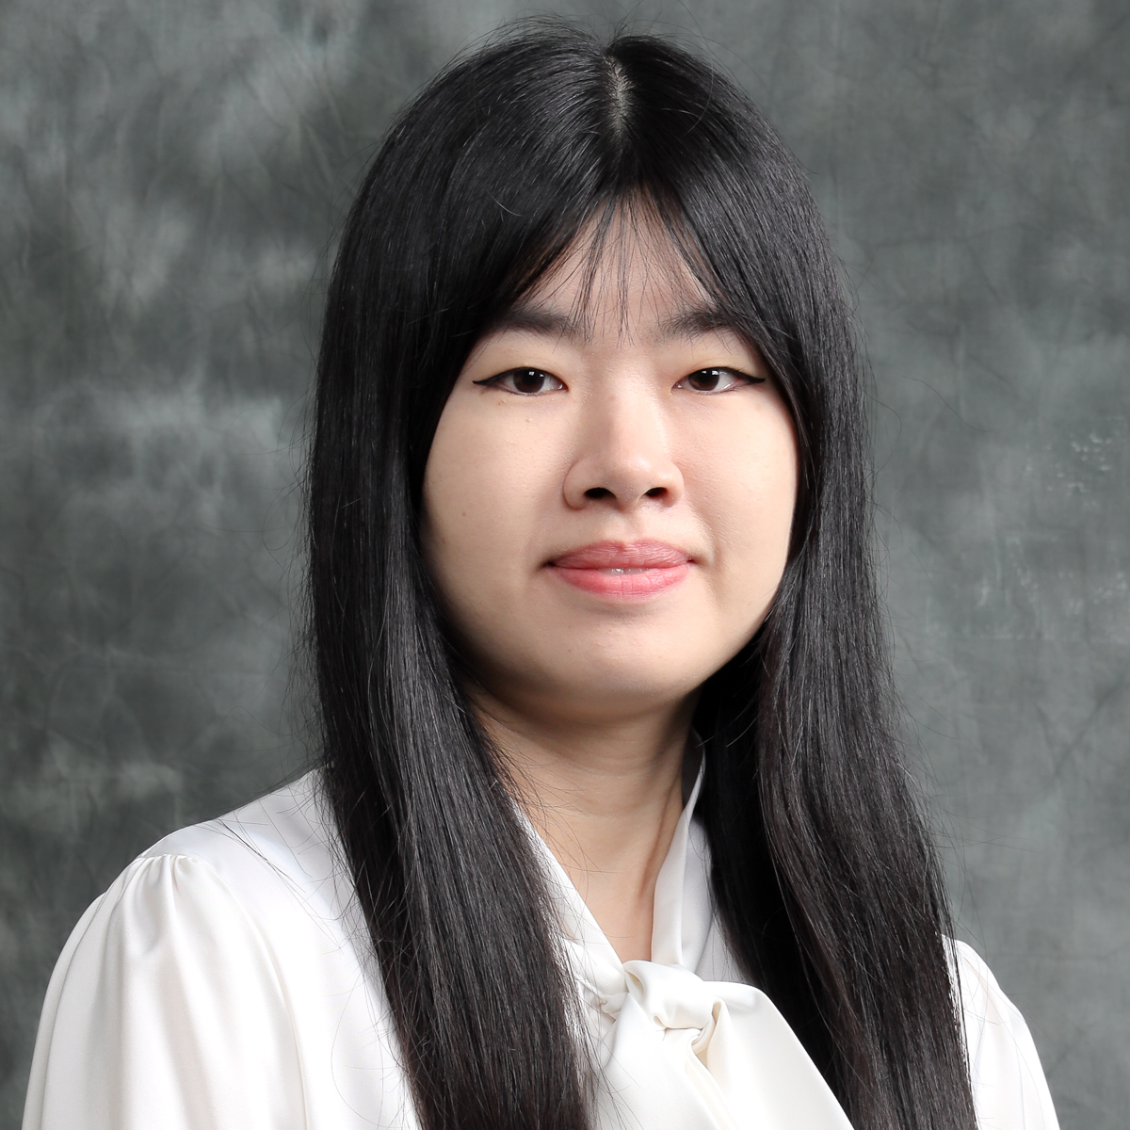 | CURRICULUM VITAE  Dr Chin Chee Ling  Faculty of Economics and Business  Universiti Malaysia Sarawak (UNIMAS)  94300 Kota Samarahan  Sarawak, Malaysia. | 









082-584378 | chlchin@unimas.my

1. PROFESSIONAL PROFILE

2. ACADEMIC QUALIFICATION
(Qualification), (Discipline), (Institution), (Year)
Doctor of Philosophy, Finance, Universiti Malaysia Sarawak, 2023
Master of Science, Finance, Universiti Malaysia Sarawak, 2017
Bachelor (Hons), Finance, Universiti Malaysia Sarawak, 2014

3. PREVIOUS APPOINTMENT
(Post), (Organisation), (From)-(Until)
#{appointmentList}

4. AREAS OF EXPERTISE
(Main), (Sub/Area)

5. RESEARCH
(Project title), (Source), (Role in Project), (From)-(Until)
The Moderating Role of Institutional Ownership in the Relationship between Share Repurchases and Shareholder Wealth: Evidence from the FTSE4Good Bursa Malaysia (F4GBM) Index, Head / Project Leader, 2025-2027, null

6. CONSULTANCY
(Title)

7. AWARDS AND RECOGNITION
(Name of Awards), (Awarding Institution), (Year), (Level)

8. PUBLICATION
(Publication)
Belawan, D. J. & Chin, C. L. (2025). The nexus between board composition and firm performance: Evidence from the F4GBM Index. UNIMAS Review of Accounting and Finance, 9(1), 154-164.
Suel, C. L. & Chin, C. L. (2025). Corporate Determinants of Dividend Policy: Empirical Evidence from Malysian Public Listed Firms. UNIMAS Review of Accounting and Finance, 9(1), 185-194.
Chin, C. H., Kho, I. Y. X., & Chin, C. L. (2025). Do human-like designed (anthropomorphism) artificial intelligence (AI) language platforms influence usage intentions among youths?. Global Knowledge, Memory and Communication, 1(1), 1-1.
Chin, C. H., Chan, W. C., Li, M., & Chin, C.L. (2025). Revealing the competitiveness of rural tourism: Exploring tangible and intangible resources in Sarawak (Malaysia) and Henan Province (China). Geojournal of Tourism and Geosites, 58(1), 18-31.
Chin, C. L,. Jais, M., & Sahari, S. (2023). The impact of dividends on future earnings : Evidence from Malaysian public listed companies. International Journal of Academic Research in Business and Social Sciences, 13(2), 1344-1359.
Chin C.-L., Jais M., Sahari S. and Chin C.-H. (2023). Information Content of Share Buybacks from an Earnings Perspective Kandungan Maklumat Pembelian Semula Saham dari Perspektif Pendapatan. Jurnal Ekonomi Malaysia, 57(1), 1.
Chin C.-L., Jais M. and Balia S.S. (2018). Predictive power of candlestick in Malaysia: Reversal versus continuation patterns. International Journal of Economics and Business Research, 15(3), 325-349.
Chin C.-L., Jais M., Balia S.S., Ahmad A.C. and Abidin A.Z. (2016). Candlestick charting and trading volume: Evidence from Bursa Malaysia. International Review of Management and Marketing, 6(8Special Issue), 153-165.

9. POST GRADUATE SUPERVISION
(Student’s Name), (Degree), (Thesis Title), (Year Awarded),
(Status), (Role)
Edward Entili Anak Nicholas, MBR, Ownership Structure As a Moderator In The Interaction Of Share Repurchases And Shareholder Wealth: Evidence From Esg-oriented Firms In Malaysia., - , In Progress, Main Supervisor
Lai Hui Ing, PHD, The Impact Of Implementation Of Data Analytics And Artificial Intelligence (ai) Technology On Audit Quality And Its Contribution To The Corporate Governance Score, - , In Progress, Co Supervisor
Aaqib Ali, PHD, "exploring The Paradox: Financial Inclusion And The Increase In Poverty - a Critical Analysis", - , In Progress, Co Supervisor
Aulia, PHD, Model Perakaunan Berasaskan Cloud Accounting Dan Implikasinya Terhadap Prestasi Kewangan Usaha Mikro, Kecil, Dan Menengah (umkm) Di Provinsi Sumatera Utara, - , In Progress, Co Supervisor

10. TEACHING
(Course name), (Code)





Research Progress, Corporate Finance, Corporate Finance for Accounting, Market and Financial Services, Mergers, Acquisition and Corporate Control, Corporate Financial Statement Analysis, Corporate Finance for Accountants

