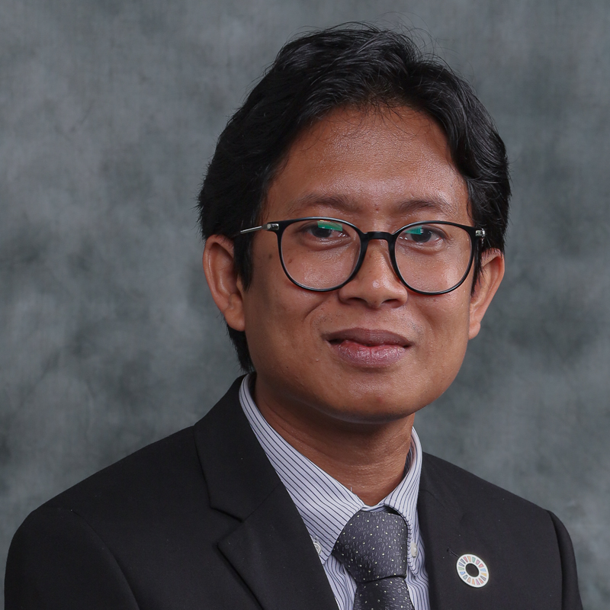 | CURRICULUM VITAE  Dr Ahmad Syafiq bin Ahmad Nasir  Faculty of Resource Science and Technology  Universiti Malaysia Sarawak (UNIMAS)  94300 Kota Samarahan  Sarawak, Malaysia. | 









082-582892 | anasyafiq@unimas.my

1. PROFESSIONAL PROFILE
Dr. Ahmad Syafiq Ahmad Nasir, a Senior Lecturer at the Faculty of Resource Science and Technology and Deputy Director (Community Transformation) at the University Sustainability Centre (USC), UNIMAS, is a recognized expert in aquaculture and fisheries. Holding a PhD in Aquaculture from UNIMAS and a Master’s degree from National Taiwan Ocean University, his specialization is in aquatic biology and sustainable aquaculture. His significant work includes projects on captive breeding and aquaculture conservation of indigenous fish species.
He is a committed advocate of community-based participatory research (CBPR), promoting inclusive collaboration and capacity building through the Pentahelix collaboration framework, bridging academia, government, industry and local communities. With over eight years of community involvement, he has successfully implemented community-focused projects that empower local voices and encourage collective decision-making. His leadership spans diverse communities, including fishing communities in Peninsular Malaysia and indigenous groups in Sabah & Sarawak.
His previous industry experience, including working under the Sarawak Corridor of Renewable Energy (SCORE) initiative, enabled him to make contributions to impactful community and conservation projects. He leads and collaborates on several grants addressing invasive species management and socio-economic development in Malaysia, establishing him as a respected researcher with publications in aquatic biology and reproductive aquaculture.
Alongside research, he is deeply involved in teaching undergraduate and postgraduate courses. His commitment to community service is reflected in his efforts on endangered species conservation, poverty alleviation and sustainable aquaculture practices throughout Sarawak. As an active member of the Malaysian Fisheries Society and the American Fisheries Society, he is dedicated to advancing environmental stewardship and community engagement across Malaysia.

2. ACADEMIC QUALIFICATION
(Qualification), (Discipline), (Institution), (Year)
Doctor of Philosophy, Aquaculture, Universiti Malaysia Sarawak, 2018
Master of Science, Aquaculture, National Taiwan Ocean University (NTOU), 2012
Bachelor of Science (Hons), Aquatic Resource Science And Management, Universiti Malaysia Sarawak, 2010

3. PREVIOUS APPOINTMENT
(Post), (Organisation), (From)-(Until)
#{appointmentList}

4. AREAS OF EXPERTISE
(Main), (Sub/Area)
Biodiversity and Conservation, Freshwater Biodiversity and Conservation
Biodiversity and Conservation, Marine Biodiversity and Conservation
Marine Toxicology, Other Marine Toxicology n.e.c.
Coastal Zone Management, Socio-Economics of Coastal Communities
Coastal Zone Management, Integrated Coastal Zone Management
Marine Social, Education and Awareness, Education and Awareness of Coastal Communities
Fisheries Sciences, Ornamental/ Aquarium Fish and Plants
Fisheries Sciences, Fish Stock Assessment (Including Mapping, Monitoring and Modelling)
Fisheries Sciences, Feed Formulation for Marine, Freshwater, Brackish and Ornamental
Aquaculture, Brood Stock Management (Including Fry Production)
Aquaculture, Fish Reproduction
Aquaculture, Fish Nutrition
Aquaculture, Culture System
Community Development, Community Research
Aquaculture Industry, Aquaculture Industry
Community Services, Community Services

5. RESEARCH
(Project title), (Source), (Role in Project), (From)-(Until)
Establishment of breeding program of Siamese fighting fish, Betta splendens for ornamental fish industry in Sarawak, Head / Project Leader, 2020-2022, Small Grant Scheme (Not offered starting from 2021-rebranding to PILOT)
Puffer Fish Oils: Isolation, quality indicies and bioactivities Assessment, Co-Researcher, 2020-2022, Luar (Nasional)
Production of Super Male Tilapia in YY Technology using Herbal Feed Treatment, Co-Researcher, 2020-2024, Luar (Nasional)
Diversity of indigenous Betta fish from Sarawak for captive breeding purpose, Head / Project Leader, 2021-2024, Fundamental Research Grant Scheme
Safeguarding of National Park from Invasive Species Invasion and Conservation of Endangered Temoleh in Tahan Basin, Pahang, Co-Researcher, 2022-2024, Luar (Nasional)
Kajian Pemetaan dan Pemantauan KIR bagi Pembasmi Miskin Tegas Keluarga Malaysia Fasa 1, Co-Researcher, 2022-2025, Luar (Nasional)
Kajian Impak di Bawah Projek Rintis Impak Sosial Petronas Menyemai Masa Hadapan untuk Yayasan Hijau Malaysia dan Petronas, Co-Researcher, 2024-2024, UHSB (Industrial Grant)
Penggunaan Smartphone dalam Penghasilan Kandungan Digital: Kajian Keberkesanan Latihan Video di Kampung Peros, Co-Researcher, 2025-2026, External Grant
Elucidating the Effects of Black Soldier Fly Larvae and Dietary Frass as Meal Replacement on the
Growth and Resistance of Tilapia (Oreochromis niloticus), Co-Researcher (Next Appointed Leader), 2025-2028, Fundamental Research Grant Scheme
Research Project on Community Empowerment through Environmental Education to Combat Illegal Dumping in Padawan, Co-Researcher, 2026-2027, UHSB ( Contract Research )

6. CONSULTANCY
(Title)
Community Outreach Framework Development, Baseline Study and Community Engagement in Belaga and Sungai Asap, Petroleum Sarawak Berhad, Project Manager, 2024 - 2024, National
Stakeholder Engagement for Marine Traffic and Risk Analysis (MTRA) for the Proposed Development of Marina and Reclamation Works at Damai Peninsula, Spartan Maritime (M) Sdn Bhd, Head / Project Leader, 2025 - 2025, National
Kajian bagi Projek Lestari Canvas Sustainable Socio Economic Development Ecosystem Implementation: Komuniti Angkat Geopark at Jagoi Community, Ibu Pejabat Jabatan Hutan, Project Manager, 2025 - 2025, National
Responsible Tourism - Food Forest Homestay 2025
-Sustainable Tourism and Culinary Iniative for Homestay -Kampung Siol Kandis & Kampung Annah Rais, Sarawak Tourism Board, Project Manager, 2025 - 2026, National

7. AWARDS AND RECOGNITION
(Name of Awards), (Awarding Institution), (Year), (Level)

8. PUBLICATION
(Publication)
Ahmad Nasir A.S., Zulkanaini M.A., Mahmud J., Hassan R., Mat Isa M.F. and Mohamad S. (2025). Captive breeding practices and insights on four indigenous Betta species of Sarawak. Reproduction and Breeding, 5(3), 144-152.
Harith, M.N., Zainol, N.S., Nasir, A.S.A., Latib, N, Belly, M.N.B and Yusoff, N.A.M. (2025).Zooplankton Genera from Sematan River, Sarawak: A Preliminary Inventory. Borneo Journal of Sciences & Technology, 7(2), 143-152. http://doi.org/10.35370/bjost.2025.7.2-12
Harith M., Salleh S., Ahmad Nasir A. and Mohamad Yusoff N. (2024). Diversity On A Plate : Short Notes On The Species Identity Of Seaweed 'Janggut Duyung' Sold In Kuching Wet Markets, Sarawak. Sarawak Museum Journal, 87(108), 177-188.
Abit LY, Nasir ASA, Grinang JA and Latif K 2024. Effectiveness of two synthetic hormones (LHRHA and Ovaprim) on induced breeding of the Bornean spotted barb, Puntius sealei (Herre, 1933). Journal of Aquatic Research and Sustainability, 1(2): 23-27. https://doi.org/10.69517/jars.2024.01.02.0005
Mohamad S., Nor Azmi N., Assim Z., Ahmad Nasir A., Ransangan J. and Ni R. (2024). Characterizing Fatty Acid Profiles and Evaluating Antibacterial Activity of Edible Yellow Puffer Fish, Xenopterus naritus: Fatty Acid Composition and Antibacterial Activities of Puffer Fish. Borneo Journal of Resource Science and Technology, 14(2), 31-40.
Rahim S. A. K. A. and Nasir A. S. A (2024). Tanjung Datu National Park to Samunsam (Eds). UNIMAS Publisher.
Ahmad Nasir A.S., Jesi N.I.A., George G.J., A. Rahim K. A. and Mohamad S. (2023). The Taxonomy of Naticidae Guilding, 1834 (Mollusca: Gastropoda) Collection from Sarawak Natural History Museum. Sarawak Museum Journal, LXXXVI(107), 107-128.
Ahmad Nasir A.S., Jesi N.I.A., George G.J., Harith M. N. and A. Rahim K.A. (2023). The Collection of Conidae Fleming, 1822 (Mollusca: Gastropoda) in Sarawak Natural History Museum. Sarawak Museum Journal, LXXXVI(107), 165-180.
Mohamad Taufek Z., Zakaria N., Yahya N., Ahmad Nasir A. and Bachok Z. (2022). Community Study of Brachyuran Crab at Setiu Lagoon, Terengganu, Malaysia. Borneo Journal of Resource Science and Technology, 12(2), 1.
Mahmud J., Zulkanaini M., Hassan R. and Ahmad Nasir A. S. (2022). Diversity and Distribution of Indigenous Betta Fish in Sarawak. , 1(1), 31-34.
A.Rahim K., Chong M., Ahmad Nasir A., Binti Mohamad F., Idrus F., Abdul Gulam Azad M. and Naqiuddin A. (2021). Diversity of Freshwater Fish in Fragmented Forest of Wilmar Oil Palm Plantation, Miri, Sarawak. Borneo Journal of Resource Science and Technology, 11(2), 30-37.
Ahmad Syafiq AN, Mohamad S, Mohidin M. Early life history of yellow puffer, Chonerhinos naritus (Richardson, 1848) from Sarawak, Northwestern Borneo. Aquac Res. 2020;00:1–10. https://doi.org/10.1111/ are.14593
Ahmad Nasir A.S., Mohamad S. and Mohidin M. (2017). The first reported artificial propagation of yellow puffer, Xenopterus naritus (Richardson, 1848) from Sarawak, Northwestern Borneo. Aquaculture Research, 48(8), 4582-4589.
Nasir A. S. A., Mohamad S., Mohidin M., 2017 The status of yellow pufferfish, Xenopterus naritus (Richardson, 1848) from the Southwest coast of Sarawak, Northwestern Borneo, Malaysia. AACL Bioflux 10(3):602-614.
Nasir A.S.A., Mohamad S. and Mohidin M. (2017). The status of yellow pufferfish, xenopterus naritus (Richardson, 1848) from the southwest coast of Sarawak, Northwestern Borneo, Malaysia. AACL Bioflux, 10(3), 602-614.
Zakirah, M.T., Shabdin, M.L., Khairul Adha, A.Rahim., Fatimah Atirah, M. & Ahmad Syafiq, A.N. (2016). The Effects of Different Diets on Survival of Marine Oligochaetes Worm (Oligochaeta: Tubificidae). AACL Bioflux, 9(5): 1144-1154.

9. POST GRADUATE SUPERVISION
(Student’s Name), (Degree), (Thesis Title), (Year Awarded),
(Status), (Role)
Mohd Armeen Bin Zulkanaini, MBR, Checklist Of Wild Betta Fish From Sarawak And Captive Breeding Protocols, 2025, Completed, Main Supervisor
Md. Abdul Hannan, PHD, Establishment Of Natural Mangrove Mud Crab Hatchery In Bangladesh, And Its Effectiveness With Dietary Lacto-sacc (immunostimulant) On Mud Crab Reproduction, Nutritional Digestibility, And Health Status, 2024, Completed, Co Supervisor
Deborah Renting Anak Jimmy, PHD, Elucidating The Effects Of Black Soldier Fly Larvae And Dietary Frass As Meal Replacement On Growth And Resistance Of Tilapia (oreochromis Niloticus), - , In Progress, Co Supervisor
Mohd Armeen Bin Zulkanaini, MBR, Checklist Of Wild Betta Fish From Sarawak And Captive Breeding Protocols, 2025, Completed, Co Supervisor
Filzah Binti Othman, MBR, Fish Host Identification Of Freshwater Mussels From Tropical Streams In Sarawak, - , In Progress, Co Supervisor

10. TEACHING
(Course name), (Code)





Advanced Breeding Technique, Sustainable Aquaculture Practices, Coastal Zone Management, Mangrove and Estuarine Ecology, Ethnic Relationship, Ecotoxicology, Ethnic Relationship in Malaysia, Diversity of Life, Philosophy and Current Issues, Natural Resource Management, Foundation of Enterpreneurship Inculturation

