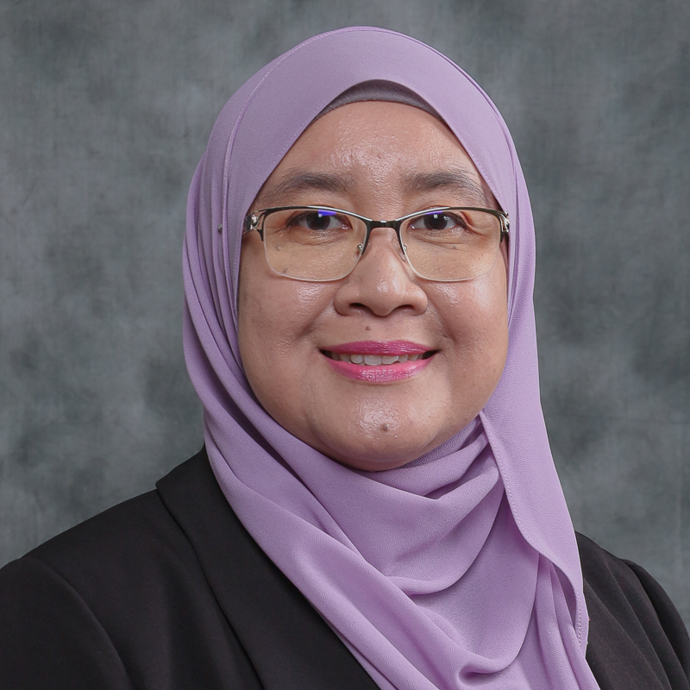 | CURRICULUM VITAE  Associate Professor Ts. Noraziah Binti Abdul Wahab  Faculty of Engineering  Universiti Malaysia Sarawak (UNIMAS)  94300 Kota Samarahan  Sarawak, Malaysia. | 









082-581001 | anoraziah@unimas.my

1. PROFESSIONAL PROFILE

2. ACADEMIC QUALIFICATION
(Qualification), (Discipline), (Institution), (Year)
Master of Engineering, Kimia, Universiti Malaysia Sarawak, 2014

3. PREVIOUS APPOINTMENT
(Post), (Organisation), (From)-(Until)
#{appointmentList}

4. AREAS OF EXPERTISE
(Main), (Sub/Area)
Chemical Engineering, Other Chemical Engineering n.e.c.

5. RESEARCH
(Project title), (Source), (Role in Project), (From)-(Until)
Study on Adsorption Behaviours of Activated Carbon in Hybrid Microbial Fuel Cell-Palm Oil Mill Effluent (POME) Treatment System, Co-Researcher, 2016-2018, Special Grant Scheme
Microbial Fuel Cell (MFC) with Algal Biocathode: Bioenergy Production and Wastewater treatment using Sago Mill Effluent, Head / Project Leader, 2016-2018, Special Top Down Grant
Study of drying characteristics for lemantak (Sarawak sago starch), Co-Researcher, 2015-2018, Fundamental Research Grant Scheme
Phytoremediation Mechanisms towards Ammoniacal Nitrogen Reduction in Industrial Effluent Discharge, Head / Project Leader, 2015-2018, Fundamental Research Grant Scheme
Developing the Project Management Competencies in Engineering Education Through the Use of Project Oriented Problem Based Learning (POPBL), Head / Project Leader, 2016-2017, Scholarship of Teaching and Learning Grants
Utilization of Sago Bark to Produce Magnetic Biochar, Co-Researcher, 2018-2020, Tun Openg Chair (Sago Chair)
Enhanced bioelectricity generation in a hybrid microbial fuel cell-adsorption system using electron mediator and electrode modification, Co-Researcher, 2019-2021, Cross Disciplinary Research
Strategic Development, Implementation and Assessment on Chemical Engineering Programme, Co-Researcher, 2019-2020, Scholarship of Teaching and Learning Grants
Phycoremediation of Landfill, Head / Project Leader, 2019-2021, UHSB (Industrial Grant)
Advanced Strategies for Modeling and Optimization of Hydrogen Production from Photo-Fermentation Microbial Electrolysis Cell using Sago Waste, Co-Researcher, 2020-2020, Luar (Antarabangsa)
Water Treatment System using Ultrafiltration, Head / Project Leader, 2019-2021, UHSB ( Contract Research )
Feasibility Study and Analysis of Water Filtration System for Rural Area in Sarawak, Co-Researcher, 2021-2023, Partners
Elucidation of Crystallization Kinetic and Thermodynamic Behaviours of Ammonium Sulphate in Wastewater via Eutectic Freeze Crystallization Process, Co-Researcher, 2022-2025, Fundamental Research Grant Scheme
Modern Farming and Sustainable Agropreneur Model for Smallholder Community in Sarawak, Co-Researcher, 2022-2025, VC-High Impact Research Grant
Data analytics dashboard of IoT-based water quality monitoring for sustainable smart farming, Co-Researcher, 2022-2025, VC-High Impact Research Grant
Designing an IoT-based Framework for JADAM Organic Farming Method, Co-Researcher, 2022-2025, VC-High Impact Research Grant
Kajian Pemetaan dan Pemantauan KIR bagi Pembasmi Miskin Tegas Keluarga Malaysia Fasa 1, Head / Project Leader, 2022-2025, Luar (Nasional)
Kajian Impak di Bawah Projek Rintis Impak Sosial Petronas Menyemai Masa Hadapan untuk Yayasan Hijau Malaysia dan Petronas, Co-Researcher, 2024-2024, UHSB (Industrial Grant)
The Role of ESG Metrics in Enhancing Corporate Social Responsibility (CSR) Initiatives to Achieve Sustainable Development Goals (SDGs) in Malaysia and Indonesia, Co-Researcher, 2025-2027, Padanan (Antarabangsa)

6. CONSULTANCY
(Title)
Bengkel Persediaan Pelajar ke arah Pendidikan Kejuruteraan (Preparing Students for Engineering Education), UNIMAS, Project Manager, 2015 - 2015, National
Cadangan Projek/Program MKMF Kampung Jagoi, Bau, Sarawak bagi Tahun 2016, Kementerian Pertanian dan Industri Asas Tani Malaysia Bahagian Pengairan dan Saliran Pertanian, Project Manager, 2016 - 2017, National
Perkhidmatan Membina Kemudahan "Covered Walkway & Lighting Arrestor" di SK Suba Buan dan "Covered Walkway & Shelter" di SK Buntal Kuching Sarawak di bawah Projek CSR Build Brigade Bersama Industri Tahun 2016, Bahagian Komunikasi Korporate Lembaga Pembangunan Industri Pembinaan Malaysia (CIDB), Project Manager, 2016 - 2017, National
Joint-Research Collaboration between UNIMAS and X-FAB Sarawak on Research Studies for Ammoniacal Nitrogen Reduction at Industrial Effluent Discharge using Phytoremediation Technology, X-FAB Sarawak Sdn Bhd, Project Manager, 2015 - 2017, National
Projek Pembekalan Sistem Air Bersih Terawat di Sekolah-sekolah di bawah Kementerian Pendidikan Malaysia (KPM) Menggunakan Sistem Water Ultrafiltration di SMK Ulu Balingian, Kementerian Pendidikan Malaysia (KPM), Head / Project Leader, 2019 - 2020, National
Projek Pembekalan Sistem Air Bersih Terawat di Sekolah-sekolah di bawah Kementerian Pendidikan Malaysia (KPM) Menggunakan Sistem Water Ultrafiltration di SMK Balleh, Kapit, Kementerian Pendidikan Malaysia (KPM), Head / Project Leader, 2019 - 2020, National
Pembekalan Air Bersih Terawat di 10 buah Sekolah Terpilih di bawah Kementerian Pendidikan Malaysia Menggunakan Sistem Water Ultrafiltration (SK Kambug, Padawan), Kementerian Pendidikan Malaysia, Head / Project Leader, 2021 - 2022, National
Socio-Economic Development Plan for Northern Region Development Agency (NRDA), Regional Corridor Development Authority (RECODA), Head / Project Leader, 2021 - 2022, National
Socio-Economic Development Plan for Upper Rajang Development Agency (URDA), Regional Corridor Development Authority (RECODA), Head / Project Leader, 2021 - 2022, National
Socio-Economic Development Plan for Highland Development Agency (HDA), Regional Corridor Development Authority (RECODA), Head / Project Leader, 2021 - 2022, National
Pembekalan Air Bersih Terawat di 10 buah Sekolah Terpilih di bawah Kementerian Pendidikan Malaysia Menggunakan Sistem Water Ultrafiltration (SK Lobang Batu, Serian), Kementerian Pendidikan Malaysia, Head / Project Leader, 2021 - 2022, National
Pembekalan Air Bersih Terawat di 10 buah Sekolah Terpilih di bawah Kementerian Pendidikan Malaysia Menggunakan Sistem Water Ultrafiltration (SK Kedumpai, Simunjan), Kementerian Pendidikan Malaysia, Head / Project Leader, 2021 - 2022, National
Pembekalan Air Bersih Terawat di 10 buah Sekolah Terpilih di bawah Kementerian Pendidikan Malaysia Menggunakan Sistem Water Ultrafiltration (SK Padang Pedalai, Simunjan), Kementerian Pendidikan Malaysia, Head / Project Leader, 2021 - 2022, National
Kajian Kebolehlaksanaan Projek Bersepadu Pembangunan Ekonomi Kampung (Prospek) Daerah Lawas, Limbang, Lembaga Kemajuan Tanah Sarawak (LKTS), Project Manager, 2022 - 2022, National
Kerja-kerja Pengumpulan Data Awalan Projek Bersepadu Pembangunan Ekonomi Kampung (PROSPEK) Kampung Sungai Mata, Samarahan, Sarawak, Lembaga Kemajuan Tanah Sarawak, Project Manager, 2023 - 2024, National
Lead Assessor for Resource Efficiency and Industrial Symbiosis Opportunity (REISO) Program - Asteel Sdn Bhd, Kuching Sarawak, SIRIM Berhad, Project Manager, 2023 - 2024, National
Execution Plan (EPP) of Socio-Economic Development Plan (SEDP) (2022-2026) for Upper Rajang Development Agency (URDA), Highland Development Agency (HRD) and Northern Region Development Agency (NRDA), Regional Corridor Development Authority (RECODA), Head / Project Leader, 2023 - 2023, National
Community Outreach Framework Development, Baseline Study and Community Engagement in Belaga and Sungai Asap, Petroleum Sarawak Berhad, Project Manager, 2024 - 2024, National
Kajian bagi Projek Lestari Canvas Sustainable Socio Economic Development Ecosystem Implementation: Komuniti Angkat Geopark at Jagoi Community, Ibu Pejabat Jabatan Hutan, Head / Project Leader, 2025 - 2025, National

7. AWARDS AND RECOGNITION
(Name of Awards), (Awarding Institution), (Year), (Level)

8. PUBLICATION
(Publication)
Wahi R., Abdul Wahab N., Atan M. and Jausus N. (2026). Empowering Society 5.0: Digitalization, Sustainability, and Global Collaboration. , 1(1), 1.
Sim C.S.F., Tan I.A.W., Ting W.H.T., Salleh S.F., Abdul Wahab N., Atan M.F., Sanaullah K. and Abdul Raman A.A. (2025). Recovery of ammonium sulfate from aqeuous solutions using freeze crystallization process. Journal of Advanced Research in Micro and Nano Engineering, 37(1), 100-111.
Tan, I.A.W., Selvanathan, J.R., Abdullah, M.O., Abdul Wahab, N., Kanakaraju, D. (2025). Effect of Different Mediators on Bio-Energy Generation and Palm Oil Mill Effluent Treatment in an Air-Cathode Microbial Fuel Cell-Adsorption System. In Technologies of Water and Wastewater Treatment. Section II (pp 412-423), Trans Tech Publications Ltd, Switzerland.
Ting W.H.T., Salleh S.F., Abdul Wahab N., Atan M.F., Abdul Raman A.A., Ting W.K., Kong S.L., Lam L.S. and Tan I.A.W. (2025). Simultaneous recovery of ammonium sulfate and ice from aqueous solution using eutectic freeze crystallization process. Journal of Crystal Growth, 649(1), 127956.
Mohamad, N.F., Tan, I.A.W., Abdullah, M.O., Abdul Wahab, N. and Kanakaraju, D. (2024). Simulation of hybrid microbial fuel cell-adsorption system performance: Effect of anode size on bio-energy generation and cod consumption rate. Borneo Journal of Resource Science and Technology, 14 (1), 69-79.
Ting W.H.T., Tan I.A.W., Salleh S.F., Abdul Wahab N., Atan M.F., Abdul Raman A.A., Kong S.L. and Lam L.S. (2024). Sustainable saline wastewater treatment using eutectic freeze crystallization: Recent advances, challenges and future prospects. Journal of Environmental Chemical Engineering, 12, 112919.
Mohd Asrul M.A., Atan M.F., Abdul Halim Yun H., Abdul Wahab N., Hu Hin H., Chang Hui J. and Ai Wei I. (2024). OPTIMIZATION OF MATHEMATICAL MODELING OF MICROBIAL ELECTROLYSIS CELL FOR THE PRODUCTION OF HYDROGEN FROM SAGO WASTEWATER SUBSTRATE. ASEAN Engineering Journal, 14(2), 7-17.
Fei Wong F., Abdullah M., Rong Hii Y., Ying Chang S., Abdul Wahab N., Abdul Halim Yun H., Jaafar M. and Agi A. (2023). A preliminary investigation of China Ginger and Kuching Local Ginger species : Oil extracts and synthesis towards potential greener insect repellent. Journal of Natural Pesticide Research, 6(1), 1-13.
Then, C.S., Tan, I.A.W., Ting, W.H.T., Salleh, S.F., Wahab, N.A. & Raman, A.A.A. (2023). Dynamic modelling and simulation of eutectic freeze crystallization process for recovery of ammonium sulphate from aqueous solutions. Journal of Water Process Engineering, 54, 103933.
Wan Ibrahim, W.I., Lo, M.C., Masron, T, Kulathuramaiyer, N., Md Hussain, M.H., Salleh, S.F., Abdul Wahab, N., Atan, M.F., Jausus, N., and Bunsu, A. (2022) UNIMAS SUSTAINABILITY REPORT 2021/2022. UNIMAS Publisher, Sarawak, Malaysia. ISBN 978-967-0054-18-6
Wan Ibrahim, W.I., Lo, M.C., Masron, T, Kulathuramaiyer, N., Md Hussain, M.H., Salleh, S.F., Abdul Wahab, N., Atan, M.F., Jausus, N., and Bunsu, A. (2022). UNIMAS SUSTAINABILITY MASTERPLAN 2021-2025. UNIMAS Publisher, Sarawak, Malaysia. ISBN 978-967-0054-17-9
Halimin N.M.S., Abdullah M.O., Wahab N.A., Junin R., Husaini A.A.S.A. and Agi A. (2022). Oil extracts from fresh and dried Iban ginger. Chinese Journal of Analytical Chemistry, 50(8), 1.
Tan, I. A. W., Selvanathan, J. R., Abdullah, M. O., Wahab, N. A., & Kanakaraju, D. (2021). Effect of different mediators on bio-energy generation and palm oil mill effluent treatment in an air-cathode microbial fuel cell-adsorption system. Defect and Diffusion Forum, 411 DDF, 67-78. oi:10.4028/www.scientific.net/DDF.411.67
M Y Then., S Ramesh., M A Mohd Asrul., M F Atan., H Abdul Halim Yun., J C H Lai., M R Rahman., M O Abdullah. and N Abdul Wahab. (2021). Dynamic Modeling of Hydrogen Production from Photo-Fermentation in Microbial Electrolysis Cell using Sago Waste. IOP Conference Series: Materials Science and Engineering, 1101(12040), 1-11.
Ting, W.H.T., Tan, I.A.W., Salleh, S.F. and Abdul Wahab, N. (2020). Phytoremediation of ammoniacal nitrogen wastewater using water hyacinth (Eichhornia crassipes). Research Journal of Chemistry and Environment, 24, 1-9.
Ting, W.H.T., Tan, I.A.W., Salleh, S.F. and Abdul Wahab, N. (2020). Ammoniacal nitrogen removal by Eichhornia crassipes‑based phytoremediation: Process optimization using response surface methodology. Applied Water Science, 10, 1-11.
and Centre for ICT Services U. (2018). Tag it : Understanding the new revolution, Issue 10, 2018. , 1(1), 1.
Kinidi L., Tan I.A.W., Abdul Wahab N.B., Tamrin K.F.B., Hipolito C.N. and Salleh S.F. (2018). Recent Development in Ammonia Stripping Process for Industrial Wastewater Treatment. International Journal of Chemical Engineering, 2018(1), 1.
iCGPA UNIMAS Manual
Ting W.H.T., Tan I.A.W., Salleh S.F. and Wahab N.A. (2018). Application of water hyacinth (Eichhornia crassipes) for phytoremediation of ammoniacal nitrogen: A review. Journal of Water Process Engineering, 22(1), 239-249.
Tien, W. T. H., Tan, I. A. W., Salleh, S. F., & Wahab, N. A. (2018). Phytoremediation of ammoniacal nitrogen in wastewater using eichhornia crassipes: Tolerance limit and pH study. Malaysian Applied Biology, 47(1), 29-36.
Barrabas S.B., Baini R., Sutan N.M., Yakub I., Anwar K., Zauzi N.S.A., Wahab N.A. and Sulaiman H. (2016). HC-SCR: NOx Reduction using Mn and Cu Catalysts Impregnated in Coconut and Palm Kernel Shell Activated Carbon. MATEC Web of Conferences, 87(1), 1.
Nik Amirah Farhana, Nik Ahmad Lutfi and Mohd Farid, Atan and Nazeri, Abdul Rahman and Shanti Faridah, Salleh and Noraziah, Abdul Wahab (2016) Study On Mathematical Model In Simulating Cymbopogon Winterianus Essential Oil Extraction By Steam Distillation. Journal of Applied Science & Process Engineering, 3 (1). pp. 1-16.
Tengku Ahmad Faris, Ku Yusoff and Mohd Farid, Atan and Nazeri, Abdul Rahman and Shanti Faridah, Salleh and Noraziah, Abdul Wahab (2015) Optimization of PID Tuning Using Genetic Algorithm. Journal of Applied Science & Process Engineering, 2 (2). ISSN 2289-7771

9. POST GRADUATE SUPERVISION
(Student’s Name), (Degree), (Thesis Title), (Year Awarded),
(Status), (Role)

10. TEACHING
(Course name), (Code)





Engineering Economics and Financial Management, Engineering Mathematics 3, Introduction to Chemical Unit Operations, Engineering Management, Numerical Methods and Statistics, Final Year Project 2, Engineering Economy, Quality Control and Reliability, Numerical Methods and Statistic, Engineering Management, Credited Cocurricular, Engineering Management, Process Control System, Final Year Project 1, Chemical Unit Operations 1, Engineering Ethics

