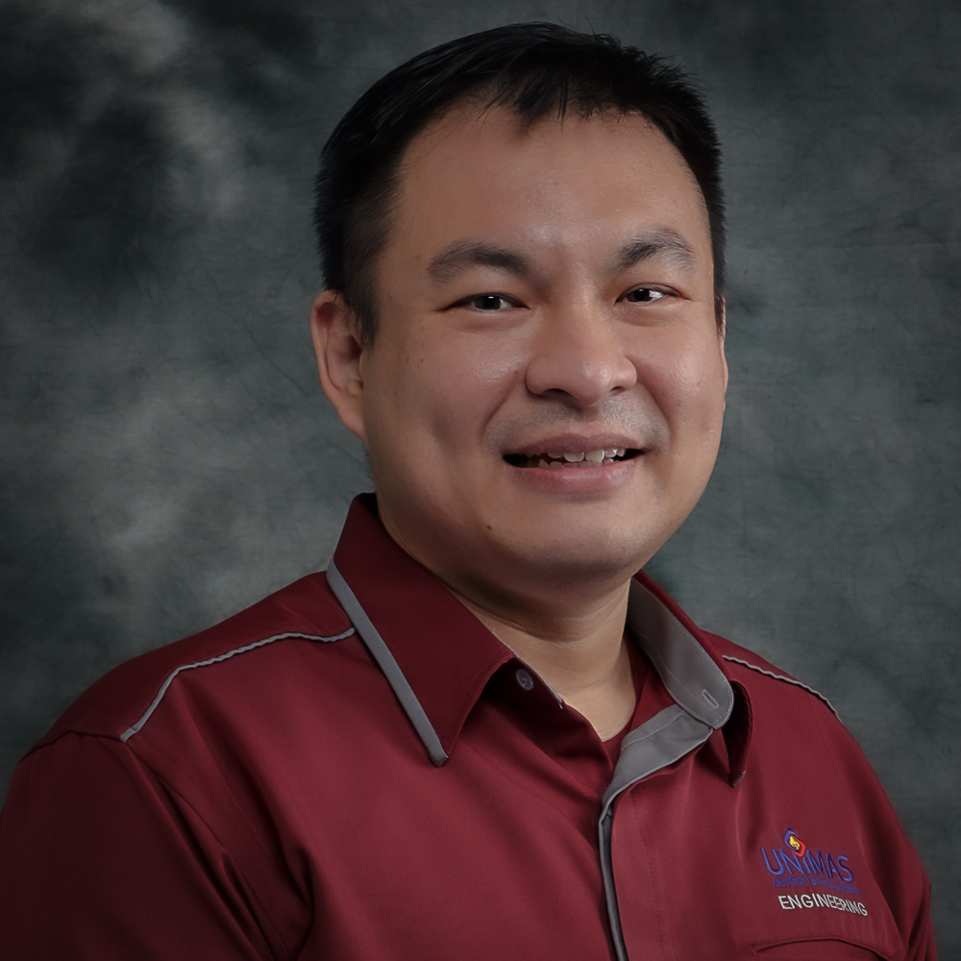 | CURRICULUM VITAE  Associate Professor Ir Dr Leonard Lim Lik Pueh  Faculty of Engineering  Universiti Malaysia Sarawak (UNIMAS)  94300 Kota Samarahan  Sarawak, Malaysia. | 









082-592624 | llpleonard@unimas.my

1. PROFESSIONAL PROFILE
Ir. Dr Leonard Lim Lik Pueh is an Associate professor in the Department of Civil Engineering, Faculty of Engineering, UNIMAS. He is a Professional Engineer registered with the Board of Engineers, Malaysia. His passion and area of expertise is in environmental engineering, which he developed an in-situ physicochemical technique for remediating groundwater contaminated with an organic compound and investigated the hydraulic performance of a membrane bioreactor for treating palm oil mill effluent. His research interest is in sustainable development for rural areas, which encompasses the management of water supply and demand, as well as the environmental monitoring and surveillance as pivotal effort for conservation of water resources and flood management. He led a community project which established an economical and sustainable solution to overcome the water supply and waste management issue in Long Lamai, and developed a natural draft biochar reactor for application in
remote areas. He has been involved in several engineering consultancy projects related to water supply and hydrology in Sarawak.

2. ACADEMIC QUALIFICATION
(Qualification), (Discipline), (Institution), (Year)
Doctor of Philosophy, Engineering, University of Cambridge, 2010
Master of Engineering, Environmental Engineering, Universiti Teknologi Malaysia, 2004
Bachelor of Engineering, Environmental Engineering, Universiti Teknologi Malaysia, 2003

3. PREVIOUS APPOINTMENT
(Post), (Organisation), (From)-(Until)
#{appointmentList}

4. AREAS OF EXPERTISE
(Main), (Sub/Area)
Physical Chemistry, Catalysis, Kinetics and Mechanisms of Reactions
Hydrology, Ground Water Hydrology
Environmental Engineering, Water Sanitary
Environmental Engineering, Sustainable Sanitation

5. RESEARCH
(Project title), (Source), (Role in Project), (From)-(Until)
Study of waste as Low-Cost Adsorbent for Groundwater Treatment, Head / Project Leader, 2011-2013, Small Grant Scheme (Not offered starting from 2021-rebranding to PILOT)
Heavy Metal Contaminated Soil Remediation Using Electrokinetics for Prevention of Groundwater Contamination, Head / Project Leader, 2012-2015, Research Acculturation Grant Scheme
Sustainable Water Purification and Soil Conditioner for Communites Living in Remote Area using Locally Synthesized Biochar, Head / Project Leader, 2015-2018, Dana Pelajar PhD
Heavy Metal Leachaability of Mosaic Sludge in Composite Binder, Co-Researcher, 2016-2018, Dana Pelajar PhD
The Mechanism and Behaviour of sewage sludge and Red Gypsum Mixture as Alternative Temporary Landfill Cover in the tropics, Head / Project Leader, 2019-2021, Luar (Nasional)
Performance Test for WenHong Stormwater Module, Co-Researcher, 2019-2020, UHSB (Industrial Grant)
A Community-Centred Educational Model for Developing Social Resilience (ACES): Playfulness Towards An Inclusive, Safe and Resilient Society, Co-Researcher, 2020-2023, Luar (Antarabangsa)
Performance of Manganese Slag-Cement Concrete: Mechanical Properties and Durability, Co-Researcher, 2020-2023, Luar (Nasional)
The Behaviour of Dewatered Sewage Sludge and Fly Ash Mix as a Potential Recycling Product, Co-Researcher, 2023-2023, Luar (Antarabangsa)
A Framework Towards Inclusive Community and Stakeholder Engagement for AquaWatch Australia (AquaWatch) Pilot Site in Sarawak, Malaysia, Co-Researcher, 2023-2024, External Grant
Scientific Study and Consolidation of Historical Marine Environmental Data as Environmental Indicators, Co-Researcher, 2023-2024, Industri Universiti
Interactive Mechanism of Biochar and Fertilizer in Enhancing Soil Nutrient Dynamics, Head / Project Leader, 2024-2027, Fundamental Research Grant Scheme
Frugal Artist-in-Residence Programme for Playful and Co-Creative Community Engagement in Environmental Awareness and Impact (FAiR), Co-Researcher, 2024-2025, Luar (Antarabangsa)

6. CONSULTANCY
(Title)
Kerja-kerja Ujian Hydraulic Conductivity di Mukah, Kuala Baram dan Lawas (2 Ujian di Tiap-tiap Kawasan), Jabatan Mineral dan Geosains Malaysia Sarawak, Project Manager, 2014 - 2015, National
Review of Hydrological Studies Component of the Studies Undertaken for Hydropower Projects in Sarawak, Sarawak Energy Berhad, Project Manager, 2014 - 2015, National
Review of Hydrological Studies Component of the Studies Undertaken for Hydropower Projects in Sarawak, Sarawak Energy Berhad, Project Manager, 2014 - 2015, National
Professional Technical Advice (PTA) Report for the Sewerage System Issue at Sarawak General Hospital, One Medicare Sdn Bhd, Head / Project Leader, 2019 - 2019, National
Consultation on Water Supply for Three Project Sites under Package 6: Water Supply and Electricity Infrastucture Projects in Telang Usan, Jurutera Perunding Promang Sdn Bhd, Head / Project Leader, 2019 - 2019, National
Detail Design Work for Drainage Upgrading at Kampung Warisan Jepak, Bintulu, Jurutera SNS Sdn Bhd, Project Manager, 2020 - 2021, National
Geran Pekamara - Sarawak Prihatin Untuk Humanitarian Disaster Relief, Persatuan Kaunseling & Psikologi MARA Malaysia, Project Manager, 2025 - 2025, National

7. AWARDS AND RECOGNITION
(Name of Awards), (Awarding Institution), (Year), (Level)

8. PUBLICATION
(Publication)
Bong C., Lim L., Ng C., Chai S., Teo F., Lai S. and Putuhena F. (2025). Conveyance Properties of Subsurface Stormwater Module. Journal of Advanced Research in Applied Mechanics, 140(1), 70-79.
Yong I., Tan I., Sim D. and Lim L. (2026). Corn Starch/Soybean Wax Double Coated Biochar‑based
Controlled‑release Nitrogen Fertilizer: Water Retention,
Release Kinetics and Okra Growth. Water, Air, & Soil Pollution, 237(397), 1-15.
Sim D., Tan I., Lim L., Yeo F., Phornvillay S., Abat M., Lam S. and Hameed B. (2025). Biochar-based slow/controlled-release fertilizer for sustainable agriculture : Recent advances, challenges and future prospects.. Journal of Environmental Chemical Engineering, 13(5), 1-17.
Ng, C. K., Ting, J. K. S., Jack, N. L., Lim, L. L. P., & Ting, S. N. (2024). The Properties of Normal Concrete with Ground Manganese Slag as Binder Replacement. Journal of Advanced Research in Applied Mechanics, 116(1), 62–74.
Rosli N., Abdul Aziz H., Lim Lik Pueh L., Othman I., Zawawi M. and Hung Y. (2024). Management of Various Sources of Hazardous Waste. , 2(27), 19-64.
Sim, D.H.H., Tan, I.A.W., Lim, L.L.P., Lau, E.T. and Hameed, B.H. (2024). Synthesis of tapioca starch/palm oil encapsulated urea-impregnated biochar derived from peppercorn waste as a sustainable controlled-release fertilizer. Waste Management, 173, 51–61.
Rosli N., Abdul Aziz H., Lik Pueh L., Othman I., Henry Adam J. and Hung Y. (2024). Stabilization and Solidification of Sludges. In Industrial Waste Engineering (pp 87-133), Springer, Cham.
Hin Joo C., Lik Pueh L., Chee Khoon N. and S. L. C. (2023). Detention Properties of Subsurface Stormwater Modules Under Tropical Climate. INTERNATIONAL JOURNAL OF INTEGRATED ENGINEERING, 15(9), 72-78.
Rosli, N. A., Abdul Aziz, H., Kueh, A. B. H., Lim, L. L. P., & Zawawi, M. H. (2023). Leaching Behaviour of Synthetic Leachate through a Sewage Sludge and Red Gypsum Composite as Intermediate Landfill Cover. Sustainability, 15(5), 4229.
Jungan, K., Lim, L. L. P., Tan, I. A. W. (2022) Determination of Suitable Biochar Precursor as Alternative for Enabling Access to Clean Water Supply in Rural Areas. Journal of Sustainability Science and Management, 17 (6), 66-78.
IVY AI WEI TAN, MIN CHONG TAN, DANIEL HONG HENG SIM, LEONARD LIK PUEH LIM AND SUK FUN CHIN (2022). MODELLING THE EFFECT OF WOOD AND MAIZE COB-DERIVED BIOCHAR APPLICATION ON SOIL DYNAMICS AND MAIZE GROWTH
FOR SUSTAINABLE AGRICULTURE. Journal of Sustainability Science and Management, Volume 17, Number 6, June 2022: 3-23.
Tan I.A.W., Tan M.C., Sim D.H.H., Lim L.L.P. and Chin S.F. (2022). MODELLING THE EFFECT OF WOOD AND MAIZE COB-DERIVED BIOCHAR APPLICATION ON SOIL DYNAMICS AND MAIZE GROWTH FOR SUSTAINABLE AGRICULTURE. Journal of Sustainability Science and Management, 17(6), 3-23.
Rosli N., Abdul Aziz H., Selamat M., Leonard Lik Pueh L. and Yung Tse H. (2022). Sewage Sludge Recycling and Disposal. , 2(1), 347-438.
Nor Azalina Rosli, Hamidi Abdul Aziz, Mohamad Razip Selamat, Leonard Lik Pueh Lim, Mohd Hafiz Zawawi, (2021), Effect of compaction on physical properties of a sewage sludge and red gypsum mixture as intermediate landfill cover, Construction and Building Materials,Volume 289,
Rosli N.A., Aziz H.A., Selamat M.R. and Lim L.L.P. (2020). A mixture of sewage sludge and red gypsum as an alternative material for temporary landfill cover. Journal of Environmental Management, 263(1), 110420.
Rosli N.A.B., Aziz H.A., Selamat M.R. and Pueh L.L.I.M.L. (2019). Physical, mechanical and chemical properties of dewatered sewage sludge and red gypsum mix as a potential recycling product. Solid State Phenomena, 294 SSP(1), 24-29.
Tan I.A.W., Shafee N.M., Abdullah M.O. and Lim L.L.P. (2017). Synthesis and characterization of biocoal from Cymbopogon citrates residue using microwave-induced torrefaction. Environmental Technology and Innovation, 8(1), 431-440.
Er, H., Bong, C.H.J., & Lim, L.L.P. (2017). A Hydrology and Hydraulic Case Study on January 2015 Flash Flood in UniGarden, Kota Samarahan, Sarawak, Proceedings of the 37th IAHR World Congress, 13-18 August, Kuala Lumpur, Malaysia, 2092-2099.
Kaman S.P.D., Tan I.A.W. and Lim L.L.P. (2017). Palm oil mill effluent treatment using coconut shell - Based activated carbon: Adsorption equilibrium and isotherm. MATEC Web of Conferences, 87(1), 1.
Tan I.A.W., Chan J.C., Hameed B.H. and Lim L.L.P. (2017). Adsorption behavior of cadmium ions onto phosphoric acid-impregnated microwave-induced mesoporous activated carbon. Journal of Water Process Engineering, 14(1), 60-70.
Ping Ling C., Ivy Wei Tan A. and Leonard Pueh Lim L. (2016). Fixed-bed Column Study for Adsorption of Cadmium on Oil Palm
Shell-derived Activated Carbon. Journal of Applied Science & Process Engineering, 3(2), 1.
Cindy L. and Leonard L. P. L. (2014). Application of electrokinetic in controlling heavy metals migration in sand: A feasibility study. UNIMAS e-Journal of Civil Engineering, 1(1), 1.
Kwong W.Z., Tan I.A.W., Rosli N.A. and Lim L.L.P. (2014). Removal of toluene from aqueous solutions using oil palm shell based activated carbon: Equilibrium and kinetics study. Pertanika Journal of Science and Technology, 22(2), 577-585.
L. L. P. Lim, R. J. Lynch (2013) Proposed field scale photocatalytic reactor for in situ groundwater remediation. Abstracts of Papers of the American Chemical Society 246, Indianapolis, USA, 8-12 September.
Lim L. and Lynch R. (2017). Feasibility study of a photocatalytic reactor for in-situ groundwater remediation of organic compounds. Journal of Hazardous Materials, 194(oct), 100-108
Lim L.L.P. and Lynch R.J. (2011). In situ photocatalytic remediation of MTBE-contaminated water: Effects of organics and inorganics. Applied Catalysis A: General, 394(1-2), 52-61.
Lim L.L.P. and Lynch R. (2011). Hydraulic performance of a proposed in situ photocatalytic reactor for degradation of MTBE in water. Chemosphere, 82(4), 613-620.
Lim L.L.P. and Lynch R.J. (2010). A proposed photocatalytic reactor design for in situ groundwater applications. Applied Catalysis A: General, 378(2), 202-210.
Lim L.L.P., Lynch R.J. and In S.-I. (2009). Comparison of simple and economical photocatalyst immobilisation procedures. Applied Catalysis A: General, 365(2), 214-221.

9. POST GRADUATE SUPERVISION
(Student’s Name), (Degree), (Thesis Title), (Year Awarded),
(Status), (Role)
Karlvin Anak Jungan, PHD, Design Of a Natural Draft Biochar Reactor For Sustainable Biomass Waste Management In Rural Areas, 2022, Completed, Main Supervisor
Huang Zhen, PHD, Research On Evaluation And Optimization Of Urban Resilience In Fuzhou City Based On The Perspective Of Emergency Management, - , In Progress, Main Supervisor
Elaine Lim Yu Ning, MBR, Suggestion: Analysis Of Rainfall And Idf Curve Development For Hydrological Design: a Case Study In Batu Kawa
note: The Title Is Subjected To Change After Corrections Have Been Made., - , In Progress, Main Supervisor
Daniel Sim Hong Heng, PHD, Encapsulated Nutrient Impregnated Biochar Fertilizer For Enhancing Soil Nutrient Dynamics, - , In Progress, Co Supervisor
Sherlynna Parveen Anak Deshon Kaman, MBR, Palm Oil Mill Effluent (pome) Treatment Using Ac/tio2 Adsorption - Photocatalysis Hybrid Process, 2020, Completed, Co Supervisor
Daniel Sim Hong Heng, MBR, Synthesis Of Tapioca Starch/palm Oil Encapsulated Urea-impregnated Biochar Controlled-release Fertilizer For Soil Amendment, 2024, Completed, Co Supervisor
Li Feng, PHD, The Effect Of Specific Surface Area Of Silicomanganese Slag As Cement Replacement On Properties Of Concrete, 2026, In Progress, Co Supervisor

10. TEACHING
(Course name), (Code)





Advanced Surface and Groundwater Hydrology, Research Project (Part 3), Wastewater Engineering, Research Project (Part 2), Research Project I, Research Methodology, Wastewater Engineering, Environmental Management Instruments and Systems, Thesis 3, Research Project (Part 1), Civil Engineering Laboratory 6, Engineering Mathematics 3, Chemical Engineering Laboratory 1, Ethics in Civil Engineering, Environmental Impact Assessment And Waste Management, Environmental Impact Assessment and Waste Management, Engineering Hydrology, Energy and Environmental Management, Civil Engineering Laboratory 3, Geo-Environmental Engineering, Energy, Environment And Society, Integrated Design Project 2, Industrial Training, Water and Waste Water Engineering, Final Year Project 2, Integrated Design Project 1, Water and Wastewater Engineering, Engineering Mathematics 2, Credited Cocurricular, Final Year Project 1, Credited Co-Curricular, Credited Co-curicular, Credited Co-curricular, Safety Management in Workplace, Credited Co-curricular (Sports), Engineering Ethics

